Team 21



Jackson McMillen

[jackson.mcmillen@uky.edu](mailto:jackson.mcmillen@uky.edu)

Garrett Cline

[garrett.cline@uky.edu](mailto:garrett.cline@uky.edu)

Chris Bodenhamer

[Bcbo226@uky.edu](mailto:Bcbo226@uky.edu)

Landon Pace

[ljpa231@uky.edu](mailto:ljpa231@uky.edu)

Tyler Davidson

[tjda237@uky.edu](mailto:tjda237@uky.edu)

Sponsored by Newton’s Attic

Class Advisors & TA’s:

Dr. Regina Hannemann [regina.hannemann@uky.edu](mailto:regina.hannemann@uky.edu)

Dr. Robert Adams [robert.adams@uky.edu](mailto:robert.adams@uky.edu)

Dr. Samson Cheung [sen-ching.cheung@uky.edu](mailto:sen-ching.cheung@uky.edu)

Harley Boyd [hwby222@uky.edu](mailto:hwby222@uky.edu)

Changpeng Ti [cti222@uky.edu](mailto:cti222@uky.edu)

Yuchen Xing [yxi270@uky.edu](mailto:yxi270@uky.edu)

**Table of Contents:**

1. **List of Tables/Figures**3
   1. List of Tables3
   2. List of Figures4
2. **Abstract**6
   1. Instructor Comments & Response6
3. **Problems Statement**6
   1. Need6
   2. Objective7
   3. Background/Technology Survey7
4. **User Story**8
5. **Requirements Specifications**10
   1. Marketing Requirements10
   2. Objective Tree11
   3. Engineering Requirements12
   4. Rationale (Engineering to Marketing Requirements Mapping)14
   5. Verification of Engineering Requirements16
   6. Design Impact19
      1. Economic19
      2. Social19
      3. Health and Safety19
      4. Standards19
      5. Manufacturability19
6. **Design**20
   1. Functional Decomposition20
   2. Behavior Model23
7. **Sub-Project Design and Testing**25
   1. Sub-Project Lead Information25
   2. Proximity Sensor Sub-Project27
   3. Power System Sub-Project32
   4. Relay Sub-Project40
   5. Game State Logic Sub-Project47
   6. GUI and Microcontroller Interface Sub-Project52
8. **Final System Integration and Verification**65
   1. Final Prototype66
   2. Testing Procedures/Fulfilled & Unfulfilled MR’s and ER’s70
9. **Project Management**72
   1. Gantt Chart72
   2. Work Breakdown73
   3. Cost77
10. **Conclusion & Reflection**79
11. **References**80
12. **Appendix**80

***1.1 List of Tables***

Table 1: Marketing Requirements9

Table 2: Engineering Requirements12

Table 3: Engineering Requirements and Rationale13

Table 4: Engineering Requirements and Verification15

Table 5: Level 0 Control System I/O Table19

Table 6: Level 1 Power System Module I/O Table20

Table 7: Level 1 Logic System Module I/O Table20

Table 8: Level 1 Motors x6 Module I/O Table20

Table 9: Proximity Sensor Relevant Marketing Requirements28

Table 10: Relevant Engineering Requirements and Related MR # for Proximity Sensor29

Table 11: Relevant Engineering Requirements Rationale Proximity Sensor29

Table 12: Relevant Engineering Requirements Verification Proximity Sensor30

Table 13: Legend for One-Line Circuit Diagram for One Target Module35

Table 14: Marketing Requirements Applicable to Power System36

Table 15: Engineering Requirements and Related MRs Applicable to Power System36

Table 16: Engineering Requirements and Rationale Applicable to Power System37

Table 17: Engineering Requirements and Verification Applicable to Power System38

Table 18: Additional Testing and Results39

Table 19: Relay Marketing Requirements42

Table 20: Relay Engineering Requirements42

Table 21: Relay Engineering Requirement Rationale43

Table 22: Relay Testing Procedures and Results44

Table 23: Additional Testing and Results45

Table 24: Marketing Requirements Applicable to Game State Logic49

Table 25: Engineering Requirements Applicable to Game State Logic49

Table 26: Microcontroller Marketing Requirements51

Table 27: Microcontroller Engineering Requirements, Related MRs and Rationale51

Table 28: Microcontroller ER Verification and Results57

Table 29: Neopixel Marketing Requirements60

Table 30: Neopixel Engineering Requirements, Related MR’s and Rationale60

Table 31: Neopixel ER Verification and Results61

Table 32: Control Box Marketing Requirements63

Table 33: Control Box Engineering Requirements, Related MR’s and Rationale63

Table 34: Control Box ER Verification and Results64

Table 35: Engineering Requirements yet to be satisfied69

Table 36: Satisfied Engineering Requirements70

Table 37: Work Breakdown72

Table 38: Cost Breakdown77

***1.2 List of Figures***

Figure 1: Target Modules in Arena8

Figure 2: User Story Arena Layout9

Figure 3: Original Target Module Decomposition9

Figure 4: High Level Overview of Updated System10

Figure 5: Objective Tree12

Figure 6: Level 0 Control System Functional Decomposition20

Figure 7: Level 1 Control System Functional Decomposition21

Figure 8: Level 2 Power System Functional Decomposition22

Figure 9: Level 2 Logic System Functional Decomposition23

Figure 10: Simple State Diagram23

Figure 11: Behavioral Flow Chart24

Figure 12: Proximity Sensor High Level Flowchart27

Figure 13: Proximity Sensor Diagram28

Figure 14: Wiring Diagram29

Figure 15: Power Supply33

Figure 16: Power Strip33

Figure 17: Auxiliary Power Supply34

Figure 18: One-Line Circuit Diagram for One Target Module35

Figure 19: Relay42

Figure 20: Relay Circuit Diagram42

Figure 21: Relay/Target Module Circuit Diagram47

Figure 22 : Finite State Behavioral Model48

Figure 23 : Main Controller Flow Chart49

Figure 24 : Peripheral Controller Flow Chart49

Figure 25 : Grand Central M4 Wiring Diagram56

Figure 26 : DB9 Control Box Wiring Diagram57

Figure 27 : DB9 Target Module Wiring Diagram57

Figure 28 : Target Module Wiring Diagram58

Figure 29 : Neopixels Early Version60

Figure 30 : Neopixels Current Version60

Figure 31 : Control Box LCD’s63

Figure 32 : Control Box Buttons63

Figure 33 : Control Box Button Board Prototype66

Figure 34 : Control Box67

Figure 35 : LCD Display Screens Mounted in the Control Box68

Figure 36 : DB9 Ports Mounted in Control Box68

Figure 37 : Initial Target Module Protoboard Progress69

Figure 38 : Target Module Protoboard Finalized69

Figure 39 : Target Module Protoboard Wiring Diagram70

Figure 40 : Team 21 Gantt Chart73

Figure 41 : AHP Table for Safety80

Figure 42 : AHP Table for Target Module80

Figure 43 : AHP Table for Logic Control and Power81

Figure 44 : Grand Central M4 Wiring Diagram81

Figure 45 : DB9 Control Box Wiring Diagram82

Figure 46 : DB9 Target Module Wiring Diagram82

Figure 47 : Target Module Wiring Diagram82

**2. Abstract**

The Robot Gladiator League is a STEM learning program for children and teenagers interested in engineering and robotics. This project will focus on improving the controls system, reliability, and safety of the systems currently in place. The Robot Gladiator league arena is currently a 20 ft by 30 ft stretched hexagon and consists of six target modules. The target modules each contain a target bowling pin, conveyer belt, motor, and circuit board. The goal of this project will be to improve the circuit design, electrical safety, game logic, and controls for the six target modules. The game logic will stop recording score after each round has been completed. This report discusses the research of design implementation, the team’s current design, project progress, sub-project breakdowns, deliverables, reasoning behind decisions, and the team’s plans to implement what is believed to be the best design.

***2.1 Instructor Comments & Response***

When writing the Final Report, comments made from the Critical Design Report, as well as the Final Presentation/Demonstration were primarily addressed in this report, along with comments made from previous assignments. In the design section of this report, we altered a few of the functional decomposition levels. This included minor updates to make it relevant to the current design such as changing the input on level 0 from proximity sensors to pin/target position, to indicate that our system is monitoring whether the bowling pin is knocked over or upright as an input to our control box. This change was carried throughout the remaining levels as well. Additionally, labels were added to make communication between specific inputs and outputs more detailed as to what each of them are, i.e. digital signal of 0/1 or voltage (5V, etc.). Other changes we made include excluding the control box, adding a second proximity sensor, changing the “main controls” to “logic system”, eliminated code modules to avoid confusion. Our section detailing each sub-project has been updated to be relevant to the current final design, as well as including any final testing and their results. An updated cost section was implemented, with our total final cost added, as well as a breakdown of how each sub-system contributed to our overall budget. Finally, a conclusion/reflection section was added to detail what our group has learned from this project as well as what we would have done differently given the opportunity to again.

**3. Problem Statement**

This section details the need, objectives, and background associated with our project. This aids the reader in understanding the purpose, or problem, associated with our project and why we are being asked to complete this.

***3.1 Need***

Newton’s Attic is a local non-profit organization that seeks to inspire and educate future generations of engineers. One of Newton’s Attic’s projects is the Robot Gladiator League. The Robot Gladiator league is a STEM learning program that closely mirrors traditional sports team dynamics. Students work in teams to learn about the engineering process and compete in tournaments. Due to the games popularity in the USA, this is a very popular avenue for engaging the youth in the STEM field, resulting in a higher need to eliminate problems that may deter any prospective kids/teenagers from beginning engagement. In its current state, the Robot Gladiator League’s control system has a very low reliability which hampers the pace of play. Additionally, the sponsor, Newton’s Attic, seeks to increase reliability and increase the pace of play by implementing a revamped controls system. By increasing reliability and pace of play, Newton’s Attic believes that they will be better equipped to inspire the next generation of engineers. Furthermore, the circuit design of the electrical systems needs a safety overhaul. It is important that this arena does not endanger anybody involved.

***3.2 Objective***

The objective of this project is to improve the controls system, power delivery, pace of play, and reliability of the current arena. Our design will improve the game logic by ensuring that scoring is accurate. We plan to accomplish this by writing a program that only updates the score when a bowling pin is fully knocked over within the constraint of the round time limit. The controls system will be capable of resetting the knocked over bowling pins at the end of each round. LEDs will be incorporated to communicate the state of the bowling pin target module. We will be improving the safety of the power delivery system by implementing a circuit breaker system. By improving the safety of the power delivery system, we will be ensuring the protection of the equipment, the Newton’s Attic team, and the spectators. The design will also communicate game logic to the scoreboard GUI which is being developed by a member of the Newton’s Attic group.

***3.3 Background/Technology Survey***

One existing technology that relates to the project of improving the controls system, reliability, and safety of the Robot Gladiator League arena is industrial automation and control systems. These systems encompass a range of technologies and methodologies aimed at automating processes and enhancing control over machinery and equipment. Specifically, technologies such as programmable logic controllers (PLCs), sensors, actuators, and human-machine interface (HMI) panels can be utilized to streamline operations, improve safety, and enhance reliability in the arena. Integrating advanced circuit design and electrical safety features aligns with the principles of industrial automation, ensuring robust performance and mitigating risks associated with electrical components. The target modules each utilize two limit switches, a 110VAC motor, a relay, a motor speed control unit, a proximity sensor, and two DB9 connectors. Each target module is connected by DB9 cables to the central judge panel where judges manually turn on motors and update the score. LEDs at the judge panel indicate when the proximity sensors detect a knocked-over bowling pin. Score updates are entirely manually inputted. An example of one side of the arena used for the current operating system can be seen in Figure 1. below.

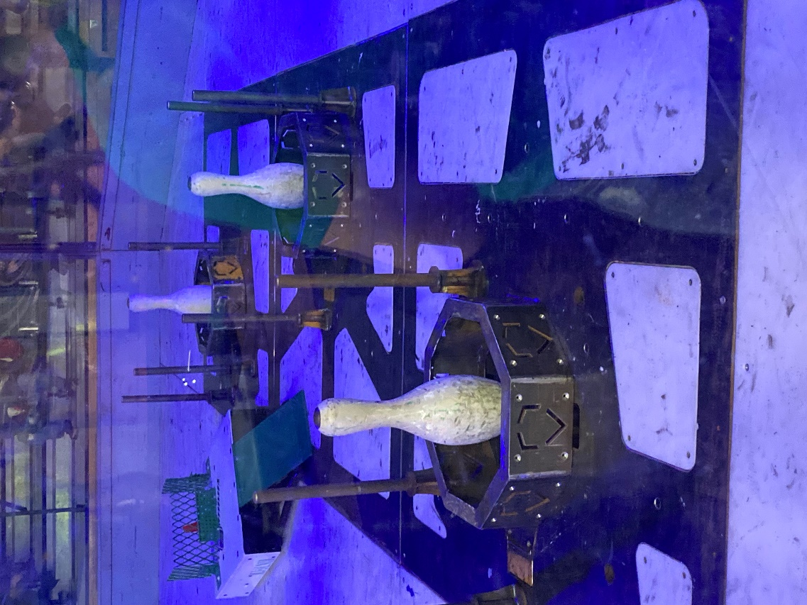

***Figure 1. Target Modules in Arena***

**4. User Story**

As previously mentioned, Newton’s Attic created the Robot Gladiator League to promote STEM learning, teach local high school students basic engineering skills, and demonstrate that engineering can be fun. The Robot Gladiator League organizes various tournaments throughout the year between local high school students. Contestants in these tournaments are provided with a base model robot, asked to modify it within the constraints, and control it during the competitions with the intent of knocking over the opposing team’s target, bowling pin.

There are six target modules in the arena, as shown in Figure 2. Each target module consists of the bowling pin, sensors, LEDs, and a motor, refer to Figure 3. The Newton’s Attic team provided us with Figure 2. However, they have since updated the target module as it lies in the arena to have three metal rods surrounding the target module, as depicted in Figure 1 above. The game is set up so that each team of students possesses three robots. The primary objective of the game is to knock over the opposing team’s bowling pins before they knock over yours.

Throughout the game, judges will be monitoring the logic control system from the table labeled “Logic Control System” in Figure 2. The judges will be paying specific attention to the state of the bowling pin: upright, knocked down, or locked. Beneath the arena floor, Arduinos will be monitoring the state of the bowling pin relay information to the implemented LEDs and motors, and to relay that information to the members of the audience regarding the state of the ongoing competition. An image giving a high-level overview of the description mentioned above can be seen in Figure 4. A link to a video created by our sponsor providing additional detail on what the Robot Gladiator League is has been provided below.

What is Robot Gladiator League - https://www.youtube.com/watch?v=uef5PlIW_mI

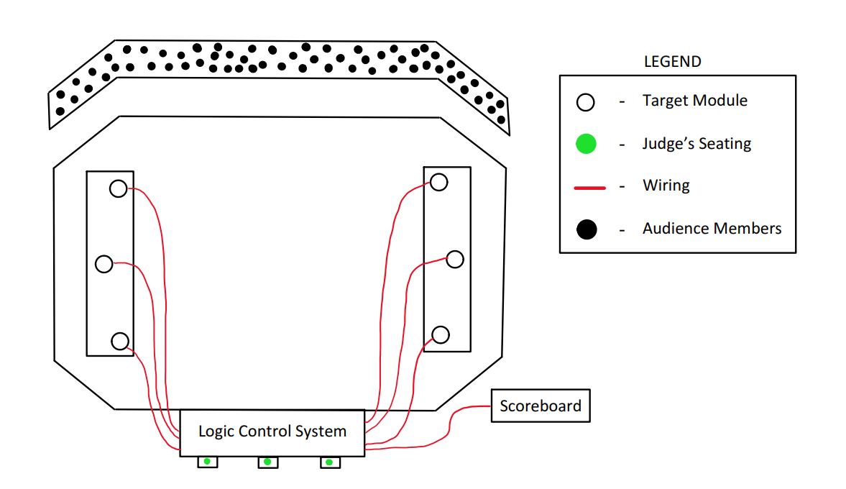

Figure 2: User Story Arena Layout

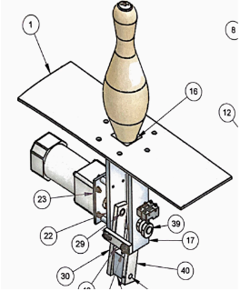

Figure 3: Original Target Module Decomposition

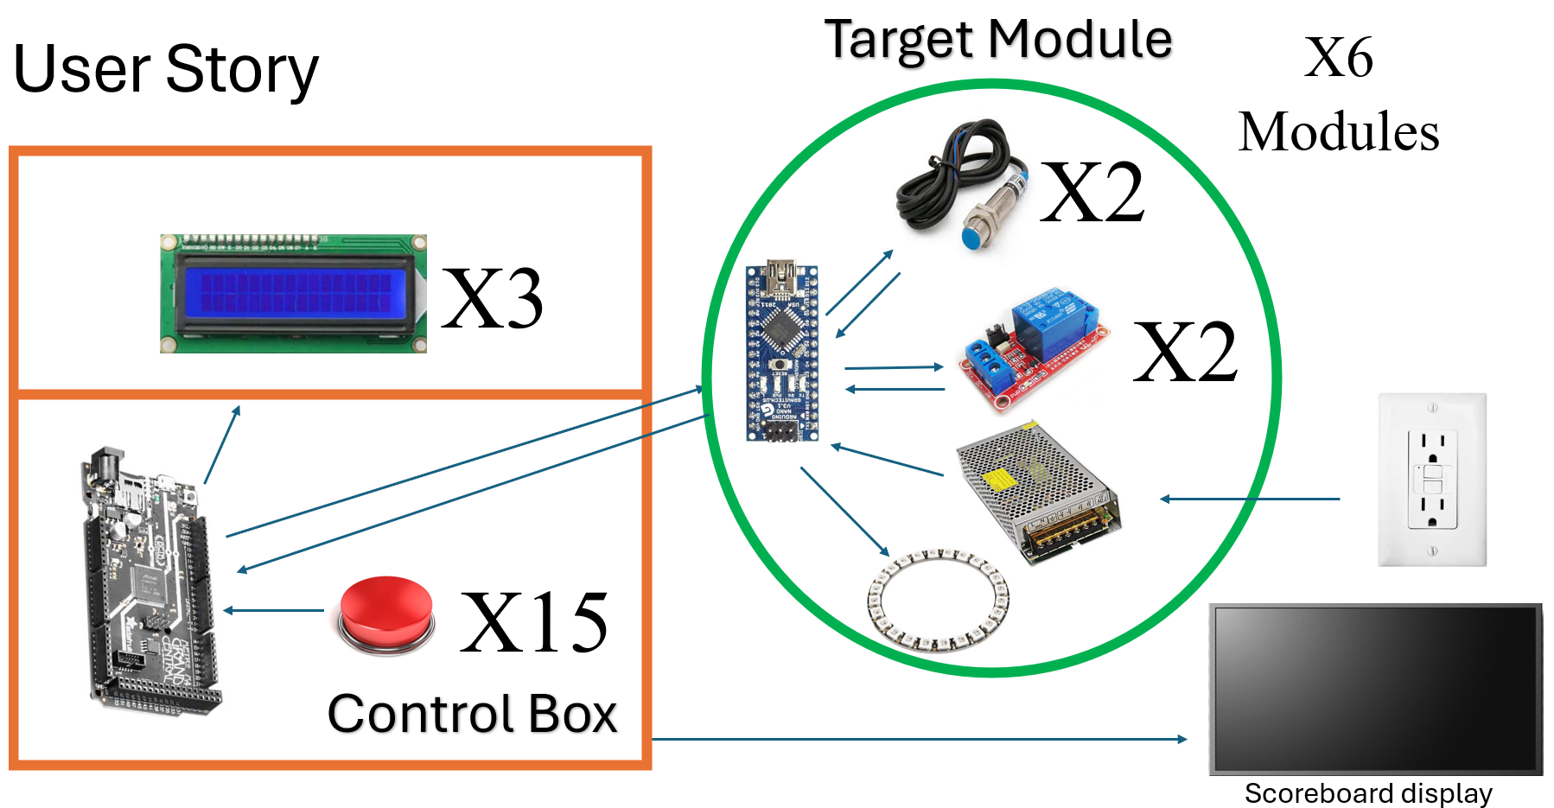

Figure 4: High Level Overview of Updated System

**5. Requirements Specifications**

This section will discuss the marketing and engineering requirements associated with our project, as well as the associated objective tree. Additionally, this section contains our impact statements and how our project affects multiple global impacts.

***5.1 Marketing Requirements***

The marketing requirements, shown below in Table 1, describe what the sponsor has requested of the project. These are objectives that our design will be striving to achieve. In this, we use some terms previously mentioned in our User Story, which will be restated here for reference. Logic control system refers to what we use to interface and control with the motors, sensors, lights, and the scoreboard system. Target module refers to the bowling pin, sensors, lights, and motor located at six positions around the arena, each identical. Target refers to the bowling pin, the physical target that is the means for the robot/contestant to interact with to score. Power system refers to the wiring, circuit breaker(s), transformers, and housing for all of the previously mentioned components. The overall system refers to the combination of all the previously mentioned systems and modules integrated within the arena.

Table 1: Marketing Requirements

|  |  |
| --- | --- |
| **#MR** | **Marketing Requirements** |
| 1 | The overall system shall comply with safety standards. |
| 2 | The overall system shall be designed with safe transport in mind. |
| 3 | The overall system shall not present any risk of harm to the user. |
| 4 | The overall system should have a low cost. |
| 5 | The logic control system shall handle inputs and outputs to the six target modules. |
| 6 | The logic control system shall have a way to take manual inputs to lock/release pins. |
| 7 | The logic control system shall be able to know the time when targets are knocked over. |
| 8 | The logic control system shall communicate with the raspberry pi-controlled scoreboard. |
| 9 | The logic control system shall have the ability to initiate a pause. |
| 10 | The logic control system and power system should be located near the announcers/judge's table. |
| 11 | The power system shall relay power to all other subsystems from the existing three phase electrical system. |
| 12 | The target module shall have LEDs used to communicate information about the status of targets. |
| 13 | The target module shall be able to lock, release, and reposition targets to their original state. |
| 14 | The interface for the target module should be kept simple. |

***5.2 Objective Tree***

From our marketing requirements we can create our objective tree as seen below in figure 5. This was created as a team by discussing what we believed was more important for the overall project. Our marketing requirements led us to 4 subcategories: Safety, Logic control, Power, and Target Module. Within these categories we weighed the importance of the corresponding marketing requirements to generate this tree. An important take away from this tree was that safety and how we managed power were going to be major components. This contributed to the design or our engineering requirements below.

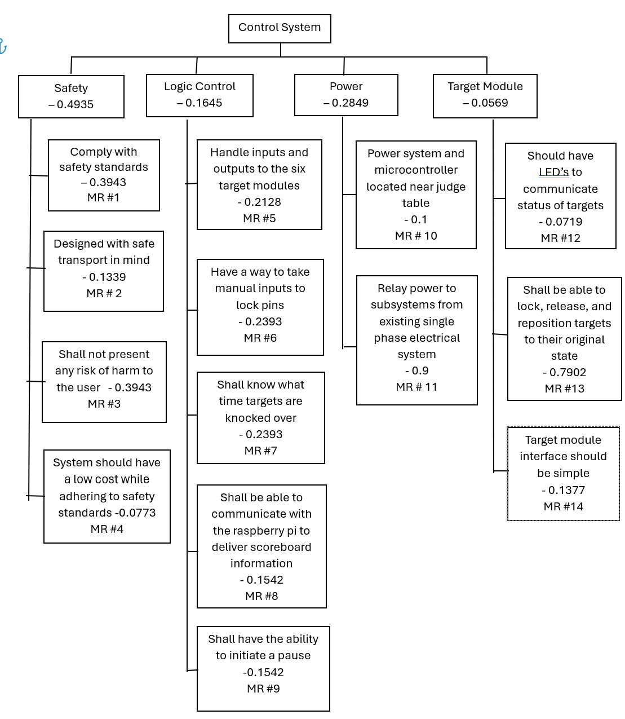

Figure 5: Objective Tree

***5.3 Engineering Requirements***

Table 2 below lists the engineering requirements for this project. In each row, the table also contains the associated marketing requirements for each engineering requirement.

Table 2: Engineering Requirements

|  |  |  |
| --- | --- | --- |
| **# ER** | **Engineering Requirements** | **Related Marketing Requirements** |
| 1 | The overall system shall contain UL listed wiring and components | 1, 3 |
| 2 | The overall system shall meet National Electric Safety code standards | 1, 3 |
| 3 | The overall system shall incorporate a shutdown switch, to kill power if necessary | 1, 3 |
| 4 | The overall system should allow prebuilt target modules to continue to be dropped into the six different designated locations | 2, 14 |
| 5 | The target module should be integrated into the overall system with little complexity (i.e. wire connectors like Push-In connectors or terminal blocks) | 2, 14 |
| 6 | The logic control system should be securely housed within a protective enclosure | 2 |
| 7 | The overall system should not exceed set budget of $300 | 4 |
| 8 | The logic control system shall use serial communication | 5 |
| 9 | The logic control system shall have at least 24 I/O pins for controls and communication, including PWM for motor control and neopixels | 5 |
| 10 | The logic control system shall be able to receive inputs from six proximity sensors | 5, 7 |
| 11 | The logic control system shall have game state logic to consider things like a round and a pause and what are viable inputs during those times | 5 |
| 12 | The logic control system shall provide accurate pin state readings | 5, 7 |
| 13 | The logic control system shall control motors within each of the six target modules | 6, 13 |
| 14 | The logic control system shall be able to take in a manual input from a button to lock pins | 6, 13 |
| 15 | The logic control system shall have an interrupt service routine for timed information | 7, 9 |
| 16 | The logic control system shall have communications with a raspberry pi providing important scoreboard information | 8 |
| 17 | The logic control system shall have an internal score tracker | 8 |
| 18 | The logic control system shall be able to take in a manual input to initiate a pause within 1 second. | 9 |
| 19 | The logic control system should be located within 5 ft of a main desk/central location | 10 |
| 20 | The overall system shall contain a power system, including relays and circuit breakers | 11 |
| 21 | The motors shall run off of 110 VAC | 11 |
| 22 | The logic control system and LEDs shall run off of 5 VDC | 11 |
| 23 | The proximity sensor shall run off of 6-36 VDC | 11 |
| 24 | The target modules each shall run off of one 110V outlet | 11 |
| 25 | The logic control system shall run 6 different neopixels (one per target module) to visually provide information about pin state | 12 |

***5.4 Rationale (Engineering to Marketing Requirements Mapping)***

Table 3 below contains the engineering requirements for this project, as well as the rationale behind each one.

Table 3: Engineering Requirements and Rationale

|  |  |  |
| --- | --- | --- |
| **# ER** | **Engineering Requirements** | **Rationale** |
| 1 | The overall system shall contain UL listed wiring and components | Reliability is necessary for functional design to be implemented for long period of time |
| 2 | The overall system shall meet National Electric Safety code standards | Safety requirements require all users of buildings power to comply with NEC safety standards |
| 3 | The overall system shall incorporate a shutdown switch, to kill power if necessary | In the event of a emergency, system needs to have a failsafe to ensure power can be completely removed from circuit |
| 4 | The overall system should allow prebuilt target modules to continue to be dropped into the six different designated locations | This will make the assembly/disassembly of the arena quicker |
| 5 | The target module should be integrated into the overall system with little complexity (i.e. wire connectors like Push-In connectors or terminal blocks) | This will allow for easier replacement of parts if need be during competition |
| 6 | The logic control system should be securely housed within a protective enclosure | Protects the circuit and users from harm and establishes a more secure connection |
| 7 | The overall system should not exceed set budget of $300 | Sponsor has allotted budget to complete project that we are not allowed to exceed |
| 8 | The logic control system shall use serial communication | Already established systems in the target modules are prepared for this |
| 9 | The logic control system shall have at least 24 I/O pins for controls and communication, including PWM for motor control and neopixels | Needs to communicate with 6 motors, 6 neopixels, 6 proximity sensors, and comms with raspberry pi |
| 10 | The logic control system shall be able to receive inputs from six proximity sensors | Needs to determine if the pins are up or down |
| 11 | The logic control system shall have game state logic to consider things like a round and a pause and what are viable inputs during those times | The game will have built in timers and logic related to game rules to ensure that the rounds work as intended |
| 12 | The logic control system shall provide accurate pin state readings | Requested by sponsor to have accurate score |
| 13 | The logic control system shall control motors within each of the six target modules | Sponsor requires independent control of each target system |
| 14 | The logic control system shall be able to take in a manual input from a button to lock pins | Requested by sponsor to add additional game variations |
| 15 | The logic control system shall have an interrupt service routine for timed information | Timing of when pins are confirmed to be knocked down is critical in determining score and pausing the game when a winner is determined |
| 16 | The logic control system shall have communications with a raspberry pi providing important scoreboard information | Sponsor plans to use a raspberry pi to control TVs presenting the score and requires communication with their system |
| 17 | The logic control system shall have an internal score tracker | Must keep track of which pins are down in order to initiate a pause at the end of game, as well as communicating with the score board module |
| 18 | The logic control system shall be able to take in a manual input to initiate a pause within 1 second. | Requested by sponsor to stop play at any point quickly |
| 19 | The logic control system should be located within 5 ft of a main desk/central location | Central location is important for ease of use |
| 20 | The overall system shall contain a power system, including relays and circuit breakers | Sponsor requested additional electrical safety to current design |
| 21 | The motors shall run off of 110 VAC | Motors require 110 VAC to function properly |
| 22 | The logic control system and LEDs shall run off of 5 VDC | The microcontroller and LEDs require 5 VDC to operate properly |
| 23 | The proximity sensor shall run off of 6-36 VDC | The proximity sensor/switch requires 6-36 VDC to function properly |
| 24 | The target modules each shall run off of one 110V outlet | Existing arena has these in place already |
| 25 | The logic control system shall run 6 different neopixels (one per target module) to visually provide information about pin state | Gives visual information about pin status and was requested by sponsor |

***5.5 Verification of Engineering Requirements***

Table 4 below contains the engineering requirements for this project, as well as the means to verify each one.

Table 4: Engineering Requirements and Verification

|  |  |  |
| --- | --- | --- |
| **# ER** | **Engineering Requirements** | **Verification** |
| 1 | The overall system shall contain UL listed wiring and components | Verify by visual inspection of components regulatory markings or datasheets |
| 2 | The overall system shall meet National Electric Safety code standards | Safety standards mention specific requirements for compliance with said standards, ensuring that users follow these standards will be measurable by physical inspections |
| 3 | The overall system shall incorporate a shutdown switch, to kill power if necessary | Use multimeter to ensure that system is recievng no voltage/current when switch is shut off |
| 4 | The overall system should allow prebuilt target modules to continue to be dropped into the six different designated locations | Verify by taking and replacing a target module and showing that the code/system works identically |
| 5 | The target module should be integrated into the overall system with little complexity (i.e. wire connectors like Push-In connectors or terminal blocks) | Time replacement of target module, and comparing against previous time to replace |
| 6 | The logic control system should be securely housed within a protective enclosure | When moving enclosure, microcontrollers position does not change |
| 7 | The overall system should not exceed set budget of $300 | Track costs of purchases to ensure budget is not exceeded |
| 8 | The logic control system shall use serial communication | Code will incorporate the serial library and use traditional serial communication |
| 9 | The logic control system shall have at least 24 I/O pins for controls and communication, including PWM for motor control and neopixels | Specs and device documentation from whatever microcontroller we go forward with meets need |
| 10 | The logic control system shall be able to receive inputs from six proximity sensors | Prove the ability to produce a different output based on the readings of all six proximity sensors |
| 11 | The logic control system shall have game state logic to consider things like a round and a pause and what are viable inputs during those times | Create a mock game in software mimicking inputs expected to be seen and observe the code proceeds through the game logic |
| 12 | The logic control system shall provide accurate pin state readings | Run code and prove the ability to produce a different output based on the multiple proximity sensors readings |
| 13 | The logic control system shall control motors within each of the six target modules | Use code running a single motor and target system through all viable pin states |
| 14 | The logic control system shall be able to take in a manual input from a button to lock pins | Run code receiving input from a button and resulting in a locked pin |
| 15 | The logic control system shall have an interrupt service routine for timed information | Verify by using two proximity sensors and produce an output, accurate to which sensor changed state first |
| 16 | The logic control system shall have communications with a raspberry pi providing important scoreboard information | Use code running comms to a raspberry pi providing information and the raspberry pi proving it is able to receive that information |
| 17 | The logic control system shall have an internal score tracker | Use code running a target module and incrementing and printing a variable, representing how many times we have knocked the pin over |
| 18 | The logic control system shall be able to take in a manual input to initiate a pause within 1 second. | Run code receiving input from a button, and time the response |
| 19 | The logic control system should be located within 5 ft of a main desk/central location | Measure the distance between the microcontroller and the main desk |
| 20 | The overall system shall contain a power system, including relays and circuit breakers | Circuit diagrams will be designed to incorporate these components, as well as a short can be simulated to verify power is disconnected |
| 21 | The motors shall run off of 110 VAC | Utilize a multimeter to ensure that the voltage input to the motor is 110 VAC |
| 22 | The logic control system and LEDs shall run off of 5 VDC | Utilize a multimeter to ensure that the microcontroller and LEDs are both receiving an input of 5 VDC |
| 23 | The proximity sensor shall run off of 6-36 VDC | Utilize a multimeter to ensure that the input voltage of the proximity sensor/switch is between 6-36 VDC |
| 24 | The target modules each shall run off of one 110V outlet | Use multimeter to ensure each target system is receiving 110V |
| 25 | The logic control system shall run 6 different neopixels (one per target module) to visually provide information about pin state | Use code running 6 neopixel arrays that can change colors based on us feeding different inputs into logic |

***5.6 Design Impact***

This section will discuss the economic, social, health and safety, standards, and manufacturability implications pertaining to our project. Each of these subsections will aid us in the selection of components and overall design.

***5.6.1 Economic***

In designing this project, we made a deliberate choice to utilize inexpensive parts, a decision anchored in practicality and foresight. By opting for cost-effective components, we not only minimize initial production expenses but also ensure affordability in maintenance and repair down the line. This approach is particularly advantageous in our context, where the target modules are destined for use in the arena. With cheaper parts, the cost of repairing target modules within the arena becomes significantly more manageable, allowing for swift and cost-effective maintenance without compromising on performance. Embracing inexpensive parts thus embodies our commitment to efficiency, longevity, and accessibility in our design philosophy.

***5.6.2 Social***

Our project is poised to ignite enthusiasm for STEM fields among local children, potentially expanding its reach as interest flourishes. By encouraging interaction with robotics, our design fosters hands-on engagement and collaborative problem-solving, laying the foundation for future innovation. Integrating reactive LED technology into the game enhances entertainment value by dynamically responding to gameplay actions, illuminating the arena with vibrant displays that heighten excitement and engagement for participants and spectators alike. Moreover, our approach prioritizes the acceleration of gameplay, injecting excitement into every moment and fueling the aspirations of budding engineers. With these elements at its core, our project not only cultivates interest in STEM disciplines but also propels the next generation towards a future enriched by technology and creativity.

***5.6.3 Health and Safety***

By enhancing the reliability of our systems, we significantly reduce the need for the Newton's Attic team to enter the arena for maintenance or repairs, thereby mitigating potential hazards associated with manual interventions. Additionally, our implementation of advanced electrical safety features, including circuit breakers, enhances the overall safety of the arena's electrical systems. These measures not only safeguard against electrical faults and overloads but also provide a robust defense against potential hazards, fostering a secure environment for everyone involved. By prioritizing both reliability and electrical safety, we aim to uphold the highest standards of health and safety in the Robot Gladiator League project.

***5.6.4 Standards***

Our design requirements are structured to strictly adhere to industry standards to ensure the safety of everyone involved in the Robot Gladiator League. Specifically, our design will be in compliance with IEC 60204-1 “Safety of Machinery – Electrical equipment of machines – Part 1: General Requirements.” This standard entails safety of persons and property (including equipment, devices, and components), consistency of control response, and ease of operation and maintenance. Additionally, our design will adhere to the National Electric Code (NEC), further ensuring the safety and reliability of our system. By aligning with these standards, we are prioritizing the safety of all participants involved in the Robot Gladiator League.

***5.6.5 Manufacturability***

Our design requirements were structured to ensure that our implementation of the control system is cross-compatible with previous designs. This entails designing the control system with efficiency and simplicity in mind, so that the changes that are made on our behalf do not negatively affect the usability of their final system. This results in minimal hard wiring, and no direct implementation into the original design. By no direct implementation, this requires that no existing components are permanently connected to new, added parts through a means of soldering, hard wiring, etc. As a result, we must ensure that anything we are adding is done in a manner that can be easily disconnected, so as not to interfere with the current working system.

**6. Design**

The purpose of the design section of the CDR is to provide the reader with a detailed description of the trajectory of the project through figures and tables. Function decomposition figures show the breakdown of each component of the system, starting generically and increasingly becoming more complex. The input/output tables are included to help the reader better understand the functional decomposition levels.

***6.1 Functional Decomposition***

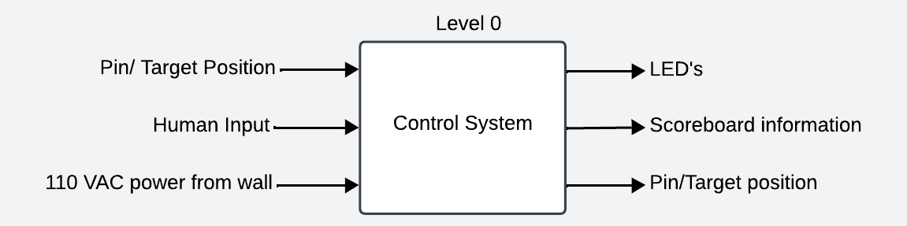

Figure 6: Level 0 Control System Functional Decomposition

Table 5: Level 0 Control System I/O Table

|  |  |
| --- | --- |
| Module | Control System |
| Inputs | Pin/Target Position: Physical pin/target position on target module  Human Input: Pause/Start buttons  Power: 110 VAC Power from wall outlet |
| Outputs | LEDs: Neopixels to show pin state  Scoreboard Information: Data from control system relevant to game scoring  Pin/Target Position: Mechanical pulley release |
| Functionality | The control system initiates the game, looks for inputs such as the pin’s positions, requires input power, utilizes buttons, recognizes the pin state from the proximity sensors on each target module, relays data from the microcontroller to the scoreboard, and utilizes LEDs to visually display the pin state. |

The level 0 functional decomposition, Figure 6, represents our control system. We are implementing this control system into a preexisting system. The level 0 functional decomposition displays the inputs and outputs of our entire system, see Table 5. The control system initiates the game, recognizes the state of the pin/target using two proximity sensors, requires an input power of 110 VAC, utilizes buttons, outputs data to the scoreboard, and outputs the pin/target’s state with the use of LEDs.

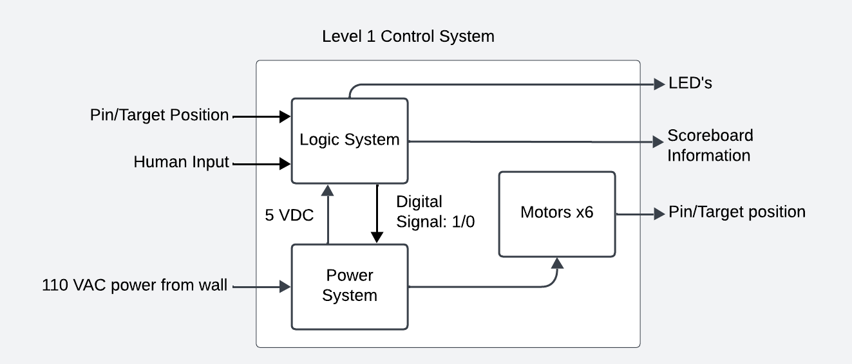

Figure 7: Level 1 Control System Functional Decomposition

Table 6: Level 1 Power System Module I/O Table

|  |  |
| --- | --- |
| Module | Power System |
| Inputs | 110 VAC Rms, 60Hz to the Power System  Digital signal from Relays to the Power System |
| Outputs | 5 VDC from Power System to the Logic System  110 VAC rms from Power System to the Motors x6 |
| Functionality | The power system receives input from main controls to determine operating state of the motors, takes 110 VAC from wall outlet, delivers 5 VDC to power the main controls, and delivers 110 VAC to operate the motors. |

Table 7: Level 1 Logic System Module I/O Table

|  |  |
| --- | --- |
| Module | Logic System |
| Inputs | Human Input: Pause/Start buttons  Pin/Target Position: Recognizes the pin state (up/down)  5 VDC from Power System to the Main Controls |
| Outputs | Relay controls from Logic System to the Power System  LEDs: Neopixels to show pin state  Scoreboard Information: Data from control system relevant to game scoring |
| Functionality | The Logic system module receives human input for game operations, utilizes the proximity sensors on each target module to recognize the state of the pin, receives 5 VDC from the Power System, outputs relay controls to the Power System, uses neopixels to visually identify pin state, and relays data from the control system relevant to overall game scoring. |

Table 8: Level 1 Motors x6 Module I/O Table

|  |  |
| --- | --- |
| Module | Motors x6 |
| Inputs | 110 VAC Rms, 60Hz from the Power System to Motors x6 |
| Outputs | Pin/Target Position: Mechanical pulley release which will receive signal from Logic System relayed to Power System to initiate activation of motors. |
| Functionality | The Motors x6 module receives 110 VAC from the power system and operates the pulley used to control that state of the pin (up/down/locked). |

The level 1 functional decomposition divides the control system into three modules: power system, logic system, and motors x6, while maintaining the overall inputs and outputs of the overall control system, refer to Figure 7. The power system receives input from the logic system to determine the operating state of the motors, takes 110 VAC from a wall outlet, delivers 5 VDC to power the logic system, and delivers 110 VAC to operate the motors, as shown in Table 6.  The Logic System module receives human input for game operations, utilizes the proximity sensor to recognize the state of the pin, receives 5 VDC from the Power System, outputs relay controls to the Power System, uses Neopixels to visually identify pin state, and relays data from the control system relevant to overall game scoring, see Table 7. The Motors x6 module receives 110 VAC from the power system and operates the pulley used to control that state of the pin (up/down/locked), shown in Table 8.

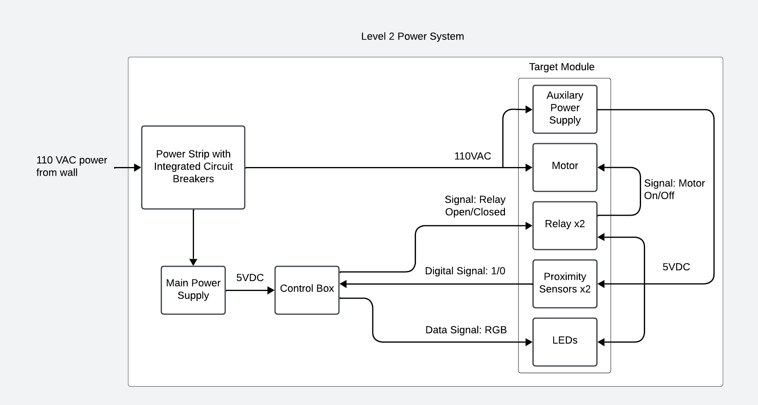

Figure 8: Level 2 Power System Functional Decomposition

The level 2 functional decomposition breaks down the entire power system module. Figure 8 displays the 110 VAC power from the wall outlet via a power strip with integrated circuit breakers that will trip whenever the input current is greater than 15A to protect the remaining system. From the power strip, an extension cord will deliver 110 VAC to the motor and a 5V, 5A power supply will be connected. 5V will be supplied to the relays, proximity sensors, LEDs, via an auxiliary power supply. The auxiliary power supply will take 110 VAC and convert it to 5 VDC. The 110 VAC for the auxiliary power supply will be tapped from the connection to the motor. The motor, relays, proximity sensors, LEDs, and auxiliary power supply, will all be located on the on the target module. The main controller will be housed in the control box and send a data signal to the LEDs to visually display the state of the bowling pin to the audience. The proximity sensors will utilize a data signal to communicate the state of the bowling pin, up or down, to the main controller. The main controller will send a signal to the relay to either open or close, which will then allow power to turn the motor on or off.

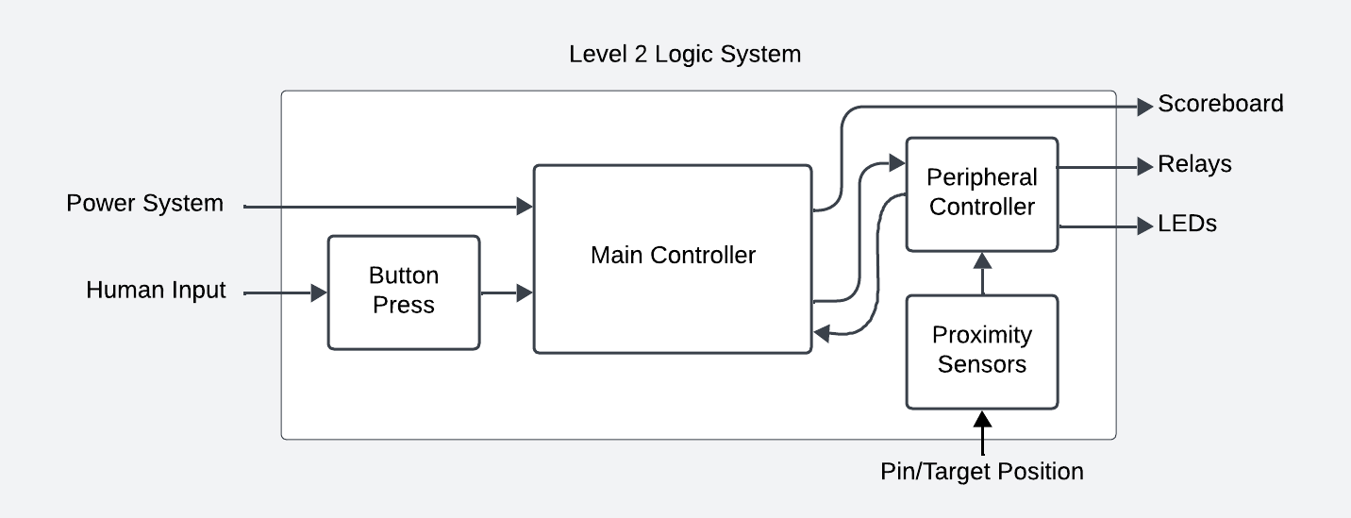

Figure 9: Level 2 Logic System Functional Decomposition

The level 2 functional decomposition of the logic system breaks down the components of the logic system. The main controller receives human input from a button press to initiate the game, and input power from the power system. The main controller will then communicate with the scoreboard and a peripheral controller. The peripheral controller will receive inputs of the pin state from the proximity sensors and communicate to the relays, LEDs, and main controller.

***6.2 Behavioral Model***

Our logic control system will be implemented through a microcontroller driving the inputs and outputs to many components within the wider game. This means our project's behavior will be best demonstrated as the game-driven behavior of the microcontroller, found in figure 9. Two behavioral models were created to demonstrate how our project will work.

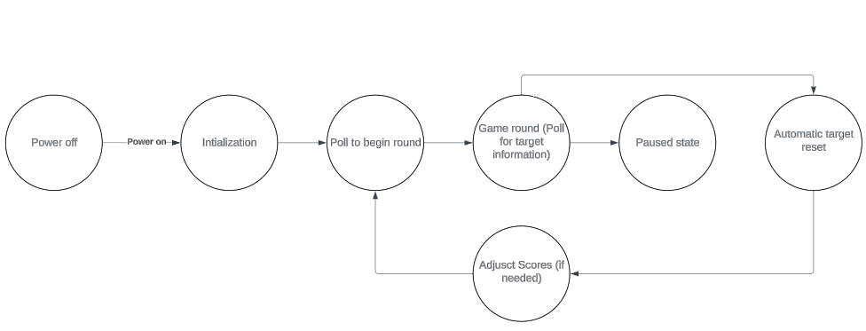

Figure 10: Simple State Diagram

In Figure 10 above you can see a simple state diagram showing the high-level behavior of our system. From power on we initialize and prepare our environment and once ready the logic control system then begins looking for the proper input to begin the round. Once received the system then moves into the game logic. It is here where we look for inputs from our sensors checking the status of targets and manipulate our peripherals such as motors and LEDs. This is expanded in Figure 11 below. Once a round is over, we return to polling for the next round. Power off returns us to the beginning.

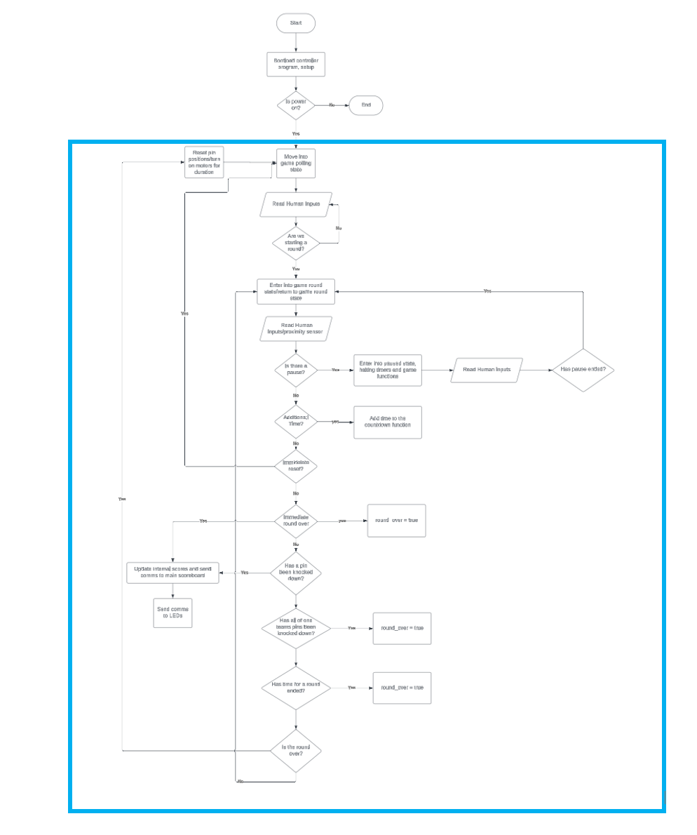

Figure 11: Behavioral Flow chart

Figure 11 above expands on the game logic state. It starts by loading the initial program. If there is no power, it ends. After the initial boot it moves into its polling state. Here it is in some form of the Arduino ‘loop state’ (shown by the blue box) which is constantly called by the processor. It performs a little differently than standard code. In this game polling state, it waits for an input to begin the game round. After it gets an input to begin the round it moves into the game round state. Here it is looking for a variety of inputs including the following: is there a pause, are they locking a pin, has a pin been knocked down, have all of one teams' pins been knocked down, has time for a round ended, and is the round over? These questions are constantly being asked within the Arduino's or another similar microprocessor loop function. If the answer is no to these questions, no action is performed. If the answer is yes, we must complete a diverging task.

If there is a pause we enter a pause state, stopping the timer and game functions. We then wait for a signal to return to the game. If we are locking a pin, we must decide if it is random or manual. We then need to engage the motors to lock the pin and send comms to the LEDs to display the state of the pins. If a pin has been knocked down (determined by the proximity sensor) we need to update our scoring variables. If one team has all their pins knocked down then we set round over to true, same if the time has run out. We then look at if the round is over and if it has been set true, we then return to the game polling state, waiting for a round to begin.

**7. Subsystem Design and Testing**

In order to create the best final product for Newton’s Attic, this project has been split into 5 sub-projects for each group member to take on and complete. Given the large integration within our system, there is a large quantity of collaboration between group members to ensure that our sub-projects fit seamlessly into the final product. This section is created to further detail each group member’s sub-project by discussing its design and integration into the final design, as well as the testing and verification that has been accomplished to ensure proper function.

**7.1 Sub-Project Lead Information**

Chris Bodenhamer is the lead for the proximity sensor. The proximity sensor operates by monitoring the target module, more specifically, the bowling within the target module; where it is monitoring the state of the pin and whether or not it is knocked over. Once it has detected that a pin has been knocked down, it will then send a digital signal to the microcontroller indicating the state of the bowling pin. With this information, we can then relay information to the judges table such as what time the bowling pin was knocked down, allowing for the judges to more accurately determine winners of a round. Chris’ involvement in the lead for the proximity sensor began with receiving Newton’s Attic’s preferred choice of proximity sensors that were previously integrated into the existing design. With these, he was then able to generate code to monitor the state of the proximity sensor, and show that it can receive an output to send to our microcontroller, notifying us what state the pin is in. With the coding portion of the project primarily accomplished, his remaining work relies on implementing the proximity sensors into the final design, where two will be utilized to more accurately determine the state of the pin.

Landon Pace is the lead for the power system sub-project. The power system’s main function in our design is to reliably, and safely provide power to the different components across the entire system, such as the motors of the target module, as well as the proximity sensors and the relays; and providing power to our microcontrollers. His work in selection of parts has primarily consisted of researching and discussing with our sponsors what solution would work best in their favor. Due to the environment that the arena exists in, there was a need expressed by the sponsors to maintain an ease of setup and teardown on behalf of the system, due to inexperienced volunteers primarily being used to aid in this process. As a result, our design has resulted in a need for easy connections that do not interfere any further in the setup process. As a result, Landon has decided on utilizing a power strip with integrated circuit breakers, to protect the large number of components existing within the system from an overcurrent event. Additionally, Landon has been responsible for adding a 5VDC, 5A power supply to deliver power to all the components mounted on the target module that are unable to utilize regular, 110VAC, wall power. Landon’s final work to the overall completion of the project involves working alongside the other sub-projects to ensure that they are all adequately receiving the input power required for safe operation through the means previously mentioned.

Tyler Davidson is the lead for the relay sub-project. The purpose of the relay within the overall system is to more precisely control the operation of the motors. The motors serve to reset the bowling pin once a round is completed. This action of resetting was done previously by the manual action of a person at a judges panel. The relay’s implementation serves to take out the human input and allow for the motors to be run to reset the bowling pin once the rounds have been completed. The work that remains to be done involves creating code to interface with the microcontroller to take the input from the judges panel that the round has been completed, therefore, automatically resetting the state of the bowling pin. Additionally, work needs to be done towards implementing the relay module on the protoboard that currently exists on each target module and wiring it in a manner that allows it to receive its digital signal from the microcontroller, as well as wiring it to receive power from the 5VDC, 5A power supply mentioned above.

Jackson McMillen is the lead for the software, particularly the game state logic. The purpose of the software is to control the microcontrollers processes for handling inputs and outputs and manage them in the context of where we are in the game. This includes creating the game state logic. In this approach we are using the design of a finite state machine. It also includes driving the logic signals across the system. We are using the Arduino IDE and environment featuring the setup() and loop() functions. Functions to operate the hardware (relays, LEDs, proximity sensors) have to be designed with these considerations in mind. Code needs to be circulating and feature no catching logic to cause issues which require a reset in the game. The purpose of our project is to reduce complexity and interaction required for operation of the robot gladiator game, this means code has to be exhaustive for all the situations that can arise.

Garrett Cline is the lead for the microcontroller implementation, neopixel lighting, and user interface. The purpose of the microcontroller is to receive all the inputs and control the various systems. Currently, there is no microcontroller, all resetting of the targets is done with manual switches directly connected to a relay which turns the motor until the limit switch disconnects power. With a microcontroller, this will be able to be automated. Additional functions will be needed to be controlled, so the current switch board will not be sufficient, so a new interface is needed. We intend to also present feedback on screens with this interface. Neopixels are addressable LEDs with existing libraries to create interesting visual feedback on the state of the targets, a feature currently not implemented. Selecting a microcontroller or microcontrollers is difficult due to the unique demands of this arena. Neopixels must be within a short distance of a microcontroller to reliably work, much longer than the spacing from the judges table, and there is one array per module for a total of 6 arrays. Additionally, there are 12 proximity sensors, 12 relays, an assortment of buttons, communication to a raspberry pi scoreboard, and displays. There have been two proposed designs, one uses an Arduino mega to control everything, with a PWM signal to an Arduino nano on each module to control the neopixels, with all inputs and outputs run back to the mega. This is a well-documented platform; however, it will be limited to expandability and has many wires to each module. The other solution is to use the Adafruit grand central M4 for its expanded SERCOM capabilities. With this, we would use serial to talk to an Arduino micro on each module, and let the modules handle the I/O and communicate that with the M4. The M4 would still be communicating with the raspberry pi, the displays, and receiving input from the buttons. However, the M4 has extremely limited documentation, and its stock configuration does not have the additional serial we need set up, so much research has been needed. Further testing is required to determine if we can successfully implement the M4 in our design, otherwise the Arduino mega will be needed.

***7.2 Proximity Sensor Design Subsystem***

The goal of this subsystem is to deliver a state detection system that quickly reports score updates to the main microcontroller. The initial plan for this subsystem to use inductive proximity sensors has not changed.

***7.2.1 Design and Integration***

The programming design concept for the proximity sensor is displayed below in Figure 12. The proximity sensor will initialize by detecting the initial state of the target module bowling pin. The proximity sensor will update the state of a target module bowling pin upon being knocked over. This updated state will trigger the game logic to update the score of the team that successfully knocked over the target after a 1 second debounce has been used to confirm a consistent state change. The purpose of the debounce is to ensure accurate score updates and eliminate the risk of a false down state due to rocking of the target bowling pins. Two proximity sensors will be implemented to ensure that the cable, which is composed of ferromagnetic material, does not give a false up state and keep score from accurately updating. A down state will be reported any time either proximity sensor loses contact with the ferromagnetic material. The code for this subsystem is in the link below. <https://github.com/TropicalShorts/RoboBowl/blob/2bc2061f84954de30fa696b9e1215146f8c98a40/DualProximitySensorReading>

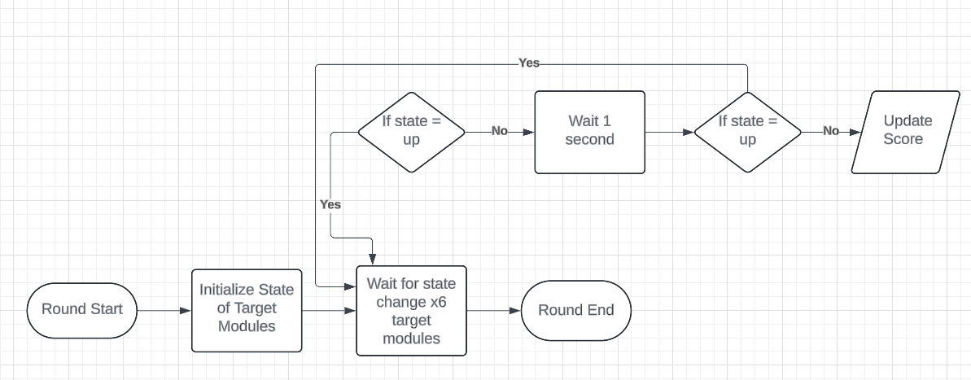***Figure 12. Proximity Sensor High Level Flowchart***

Figure 13 below shows the chosen proximity sensor. This is an inductive proximity sensor that relays a signal to a microcontroller when contact with ferromagnetic material is made. Although the proximity sensor is rated for 10-30V we will be using 5V per request of the sponsor. Testing was performed to ensure that 5V was ideal for the proximity sensor voltage supply. This testing is discussed further within section 7.2.3 and 7.2.4. Figure 14 below shows the wiring diagram of the proximity sensors on each target module.

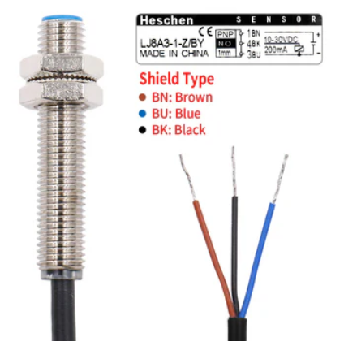

***Figure 13: Proximity Sensor Diagram***

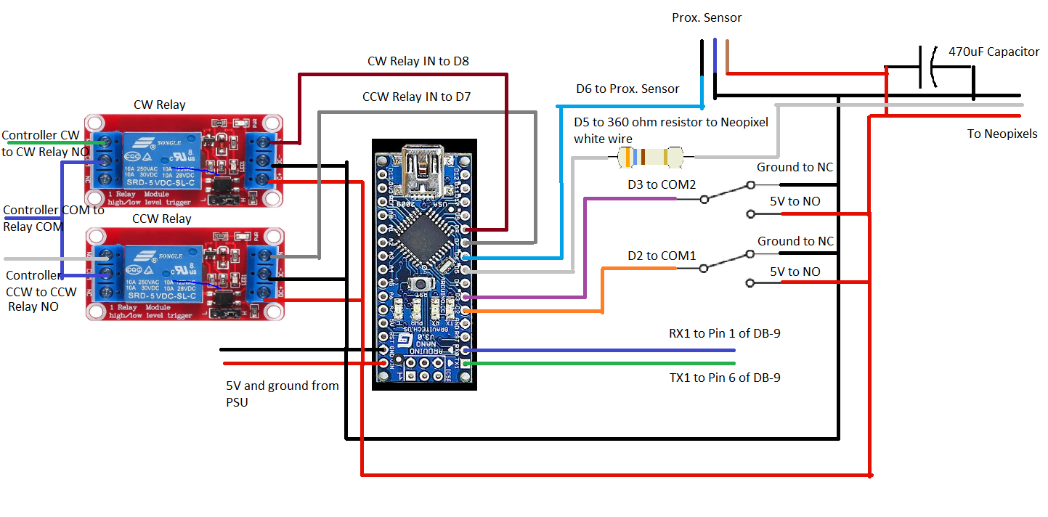

***Figure 14: Wiring Diagram***

***7.2.2 Relevant Marketing and Engineering Requirements***

These marketing requirements were created in collaboration with the rest of the team. The marketing requirements discussed in this individual progress report were selected due to their relevance to the locking system and target module bowling pin state detection system. Table 9 displays the marketing requirements relevant to the target module bowling pin state detection system.

***Table 9: Proximity Sensor Relevant Marketing Requirements***

|  |  |
| --- | --- |
| **#MR** | **Relevant Marketing Requirements** |
| 3 | The overall system shall not present any risk of harm to the user. |
| 4 | The overall system should have a low cost. |
| 7 | The logic control system shall be able to know the time when targets are knocked over. |

The marketing requirements shown above in Table 9 all directly influence the decision-making process for this sub-project. Marketing Requirements three and four are global marketing requirements that have been taken into consideration for every sub-project within the overarching RoboBowl project. Marketing requirement six is relevant to Garret Cline and Jackson McMillen’s programming oriented sub-projects as well. It is important that the locking mechanism can be manually controlled through the control system. Marketing requirement seven pertains to the target state detection of this sub-project.

The engineering requirements displayed in Table 10 were selected from the team’s combined engineering requirements table. The selected engineering requirements pertain to the sub-project discussed within the report. The corresponding related marketing requirements are indicated in Table 10. Table 11 contains the rationale behind each of the selected engineering requirements. Table 12 contains the testing and verification for each engineering requirement.

***Table 10: Relevant Engineering Requirements and Related MR # For Proximity Sensor***

|  |  |  |
| --- | --- | --- |
| **# ER** | **Relevant Engineering Requirements** | **Related Marketing Requirements** |
| 1 | The overall system shall contain UL listed wiring and components | 3 |
| 2 | The overall system shall meet National Electric Safety code standards | 3 |
| 7 | The overall system should not exceed set budget of $300 | 4 |
| 10 | The logic control system shall be able to receive inputs from six proximity sensors | 7 |
| 12 | The logic control system shall provide accurate pin state readings | 7 |
| 23 | The proximity sensor shall run off of 5-36 VDC | 7 |

Engineering requirements one and two both correspond to marketing requirement three. The goal of these three engineering requirements is to ensure the safety of the Newton’s attic team and the general public. Engineering requirement nine relates to the overall goal of keeping the price of any new components within the allotted budget. Engineering requirements 10, 12, and 23 pertain to the implementation of the proximity sensor. These three engineering requirements all correspond to marketing requirement 7.

***Table 11: Relevant Engineering Requirements Rationale Proximity Sensor***

|  |  |  |
| --- | --- | --- |
| **# ER** | **Engineering Requirements** | **Rationale** |
| 1 | The overall system shall contain UL listed wiring and components | Reliability is necessary for functional design to be implemented for long period of time |
| 2 | The overall system shall meet National Electric Safety code standards | Safety requirements require all users of buildings power to comply with NEC safety standards |
| 7 | The overall system should not exceed set budget of $300 | Sponsor has allotted budget to complete project that we are not allowed to exceed |
| 10 | The logic control system shall be able to receive inputs from six proximity sensors | Needs to determine if the pins are up or down |
| 12 | The logic control system shall provide accurate pin state readings | Requested by sponsor to have accurate score |
| 23 | The proximity sensor shall run off of 5-36 VDC | The proximity sensor/switch requires 5-36 VDC to function properly |

***Table 12: Relevant Engineering Requirements Verification Proximity Sensor***

|  |  |  |
| --- | --- | --- |
| **# ER** | **Engineering Requirements** | **Verification** |
| 1 | The overall system shall contain UL listed wiring and components | Verify by visual inspection of components regulatory markings or datasheets |
| 2 | The overall system shall meet National Electric Safety code standards | Safety standards mention specific requirements for compliance with said standards, ensuring that users follow these standards will be measurable by physical inspections |
| 7 | The overall system should not exceed set budget of $300 | Track costs of purchases to ensure budget is not exceeded |
| 10 | The logic control system shall be able to receive inputs from six proximity sensors | Prove the ability to produce a different output based on the readings of all six proximity sensors |
| 12 | The logic control system shall provide accurate pin state readings | Run code and prove the ability to produce a different output based on the proximity sensors readings |
| 23 | The proximity sensor shall run off of 5-36 VDC | Utilize a multimeter to ensure that the input voltage of the proximity sensor/switch is between 6-36 VDC |

***7.2.3 Proximity Sensor Testing Procedures***

Testing of the proximity sensor system began with writing a program to run a single proximity sensor. The goal of the initial program was to run a single proximity sensor at 5V and turn on an LED when ferromagnetic material physically contacted the proximity sensor. We then implemented a second proximity sensor circuit that mirrored the original. An LED was used to give a visual indication of function during testing. The final testing was implementing debounce logic. The debounce logic was needed to ensure that rocking motion in the bowling pins does not cause a false down state. A false down state would incorrectly update the score and potentially cause score disputes or new rounds to begin prematurely. We started a stopwatch every time the ferromagnetic material came into contact with the proximity sensor to ensure that the debounce of 1 second would be correctly implemented into the score reporting.

***7.2.4 Proximity Sensor Testing Results***

Voltages greater than 5V were found to be incompatible with the overall purpose of the sub-system. We found that the inductive proximity sensor had too high of a detection range at higher voltages. Due to the nature of the game, we fear that a higher voltage supply would make accurate detection of the target modules impossible. For this reason, we chose to continue with 5V for the proximity sensor supply.

The testing of the proximity sensor was successful. Every time the ferromagnetic material touched the proximity sensor, the LED lit up. After adding the second proximity sensor, the results were unchanged. The debounce program we implemented functioned exactly as intended. We started a stopwatch every time the ferromagnetic material came into contact with the proximity sensor and found that the LED turned on exactly 1 second after only when contact was sustained. Additionally, we verified that the program could constantly report the status of the proximity sensors to the target module microcontroller.

***7.3 Power System Sub-Project***

The purpose of the power system sub-project is to provide power to all components within the system reliable, and safe power. Our sponsor has requested that we keep modularity and durability in mind throughout the design of the power system. For one target module, the team at Newton’s Attic is currently delivering power to the target module utilizing multiple power sources. This will require additional extension cords and could complicate the assembly and disassembly of the arena. Our goal is to improve their current distribution system.

***7.3.1*** ***Power System Component Selection***

When selecting components for the power system, the safety of everyone in attendance of the competition was our priority. We also want to ensure that we satisfy the needs of our sponsor. There are various components that are encompassed in the power system. For one target module, we currently have a motor, a relay, two proximity sensors, a set of LEDs, a voltage regulator, and a microcontroller. All these components require power to operate correctly.

The team at Newton’s Attic currently utilizes a 110 VAC motor, a 5V proximity sensor, and a 5V set of Neopixels. After discussion with their team in various meetings, they are satisfied with the current state of these components, and therefore we will continue to utilize them. The only components that we will be choosing for the power system are the power supply and power strip.

We originally intended on utilizing fuses for system protection; however, this would not satisfy the needs of our sponsor. We believe they need some sort of overcurrent protection device, but a fuse would add unnecessary complexity to the competition. If a fuse was mounted on each target module, a blown fuse would require someone to climb up underneath the arena during competition each time it needed to be replaced. This was inefficient and overcomplicated. We instead chose to utilize a power strip that will have 5A circuit breakers already implemented. The power strip will adequately protect the system from overcurrent and be easily accessible to the Newton’s Attic team. We have also chosen a 5V, 5A power supply that receives 110 VAC and converts that to 5 VDC. This will allow us to deliver power to the system utilizing one source.

***7.3.2*** ***Power System Design and Integration***

Figure 15 below displays the power supply that we have chosen to use. The entire system operates at two different voltages, 110 VAC and 5 VDC. Therefore, we required a way to step the voltage down, while also converting from AC power to DC power. We chose this power supply because it was the most efficient way that we could step down the 110 VAC to 5 VDC, as it satisfies the easy connect and disconnect requirement from our sponsor and is relatively inexpensive.

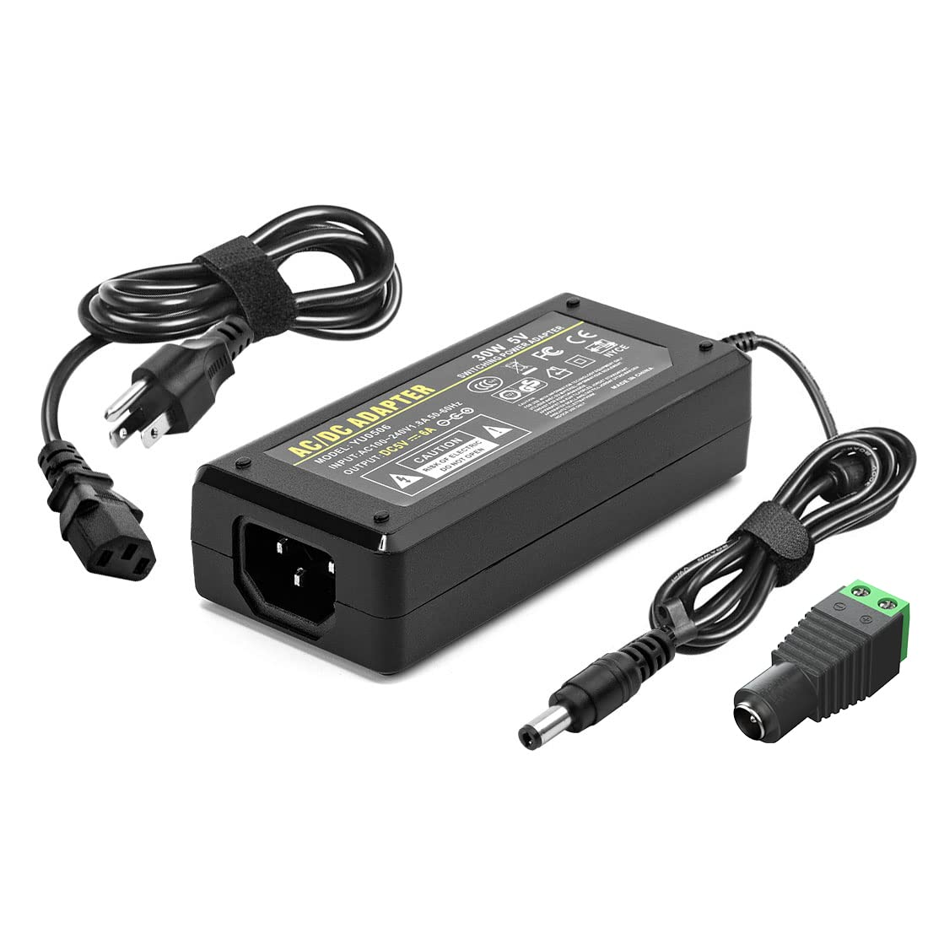

**Figure 15: Power Supply**

Figure 16 displays the power strip that we’ve selected. We chose this power strip because it will be easy to implement with the current system. The team at Newton’s Attic currently utilizes numerous extension cords that deliver power to various parts of the arena. With the use of this power strip, we will be able to deliver 110 VAC to the motor and 5 VDC via the power supply to the relay, proximity sensors, LEDs, and auxiliary power supply. The power strip has a UL listing which is part of our requirements. The power strip also satisfies the needs of our sponsor with it being easy to connect/disconnect and is relatively inexpensive.

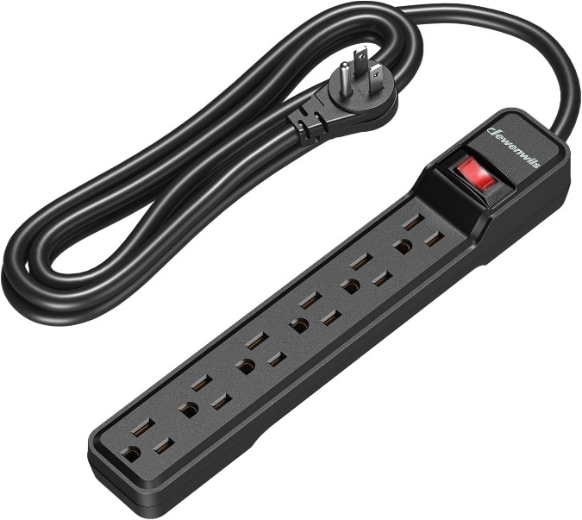

**Figure 16: Power Strip**

Figure 17 displays the auxiliary power supply that we have chosen and require. In testing, it was discovered that the Neopixels require approximately 3.6A for maximum brightness output, see equation below. Therefore, we chose to use this auxiliary power supply, as it satisfies the needs of our sponsor with it being durable and relatively inexpensive.

$$\frac{60 Neopixels*3 Colors*20mA }{1000}=3.6A$$

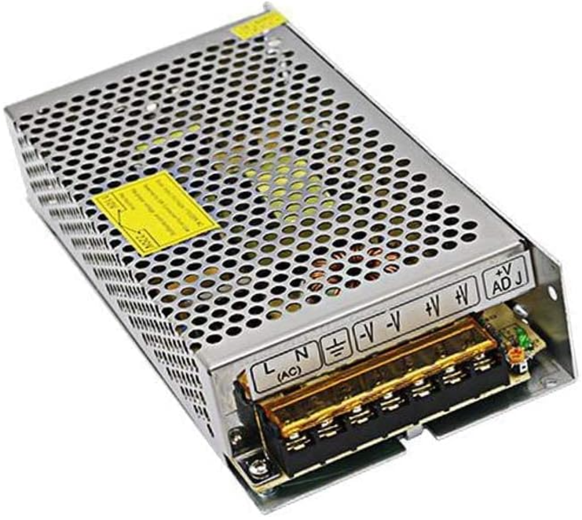

**Figure 17: Auxiliary Power Supply**

Per instructor request, we have updated our power system one-line diagram. Originally, we had our circuit diagram displaying the distribution of power to all six target modules. After discussion with the instructors during the sub-project meetings, we received feedback that this added unnecessary confusion. Figure 16 below, is our updated one-line circuit diagram for one target module. First, we will receive 110 VAC in from the wall outlet. Then, we will utilize the extra connections from the power strip to deliver 110 VAC to both the main power supply and the motor mounted on the target module. Then, we will supply the auxiliary power supply via input power to the motor. We will then utilize the auxiliary power supply to convert 110 VAC to 5 VDC and supply power to the relays, proximity sensors, and the Neopixels. Finally, we will utilize main power supply to supply 5 VDC to the control box, which houses the microcontroller. For the signals, the microcontroller will then send a data signal to the LEDs to visually display the state of the bowling pin to the audience. The proximity sensors will utilize a data signal to communicate the state of the bowling pin, up or down, to the main controller. The main controller will send a signal to the relay to either open or close, which will then allow power to turn the motor on or off. The legend for the one-line circuit diagram is displayed in Table 13.

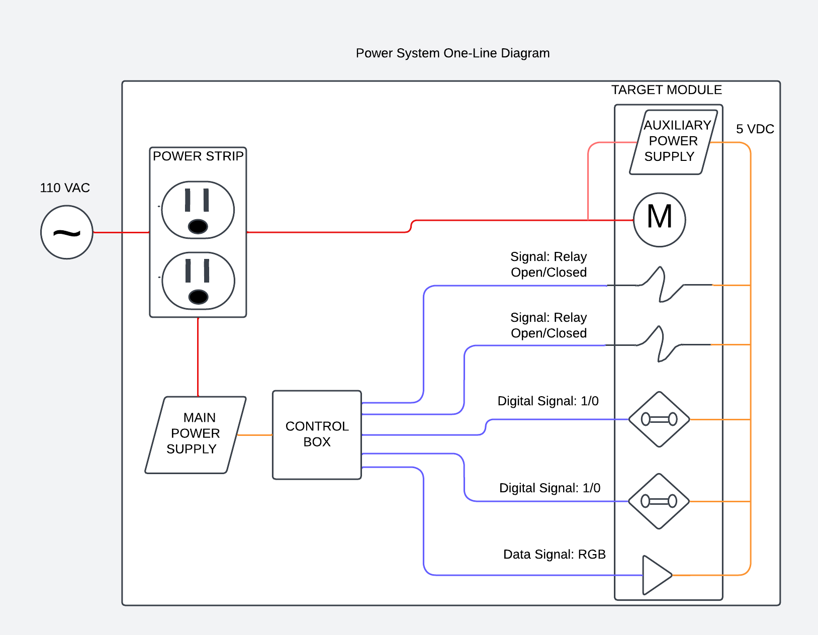

**Figure 18: One-Line Circuit Diagram for One Target Module**

Table 13: Legend for One-Line Circuit Diagram for One Target Module

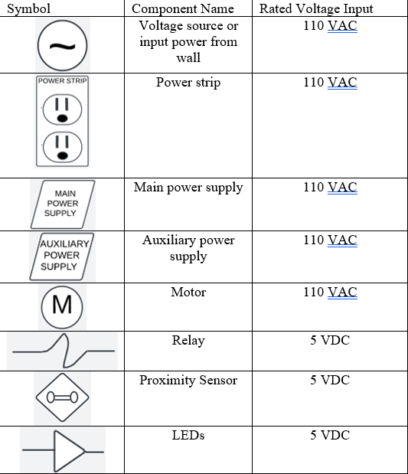

***7.3.3*** ***Applicable Power System Engineering and Marketing Requirements***

This section of the report will discuss both the marketing and engineering requirements that pertain to the power system. Table 14 below displays the marketing requirements applicable to the power system sub-project. Our project has many more marketing requirements, however, the ones listed below specifically impact the power system sub-project. Marketing requirements (MR) 1-4 are referred to as “global MRs,” meaning they pertain not only to the power system, but also to our overall project. Therefore, the power system sub-project must comply with these requirements to achieve the objectives of the overall project. Marketing requirement 10 specifically addresses the location of the power system and marketing requirement 11 addresses the distribution of power throughout the subsystems within the arena.

Table 14: Marketing Requirements Applicable to Power System

|  |  |
| --- | --- |
| **#MR** | **Marketing Requirements** |
| 1 | The overall system shall comply with safety standards. |
| 2 | The overall system shall be designed with safe transport in mind. |
| 3 | The overall system shall not present any risk of harm to the user. |
| 4 | The overall system should have a low cost. |
| 10 | The logic control system and power system should be located near the announcers/judge's table. |
| 11 | The power system shall relay power to all other subsystems from the existing single phase electrical system. |

Table 15 lists some of our engineering requirements. In the far-right column, the marketing requirements that are relevant to each specific engineering requirement are displayed. Our team has many more engineering requirements, however, the ones listed in the table below directly impact the design and implementation of the power system sub-project.

Table 15: Engineering Requirements and Related MRs Applicable to Power System

|  |  |  |
| --- | --- | --- |
| **# ER** | **Engineering Requirements** | **Related Marketing Requirements** |
| 1 | The overall system shall contain UL listed wiring and components | 1, 3 |
| 2 | The overall system shall meet National Electric Safety code standards | 1, 3 |
| 3 | The overall system shall incorporate a shutdown switch, to kill power if necessary | 1, 3 |
| 4 | The overall system should allow prebuilt target modules to continue to be dropped into the six different designated locations | 2, 14 |
| 5 | The target module should be integrated into the overall system with little complexity (i.e. wire connectors like Push-In connectors or terminal blocks) | 2, 14 |
| 6 | The logic control system should be securely housed within a protective enclosure | 2 |
| 7 | The overall system should not exceed set budget of $300 | 4 |
| 19 | The logic control system should be located within 5 ft of a main desk/central location | 10 |
| 20 | The overall system shall contain a power system, including relays and circuit breakers | 11 |
| 21 | The motors shall run off of 110 VAC | 11 |
| 22 | The logic control system and LEDs shall run off of 5 VDC | 11 |
| 23 | The proximity sensor shall run off of 6-36 VDC | 11 |
| 24 | The target modules each shall run off of one 110V outlet | 11 |

Table 16 not only lists the engineering requirements pertaining to the power system sub-project but also includes the rationale behind each one.

Table 16: Engineering Requirements and Rationale Applicable to Power System

|  |  |  |
| --- | --- | --- |
| **# ER** | **Engineering Requirements** | **Rationale** |
| 1 | The overall system shall contain UL listed wiring and components | Reliability is necessary for functional design to be implemented for long period of time |
| 2 | The overall system shall meet National Electric Safety code standards | Safety requirements require all users of buildings power to comply with NEC safety standards |
| 3 | The overall system shall incorporate a shutdown switch, to kill power if necessary | In the event of a emergency, system needs to have a failsafe to ensure power can be completely removed from circuit |
| 4 | The overall system should allow prebuilt target modules to continue to be dropped into the six different designated locations | This will make the assembly/disassembly of the arena quicker |
| 5 | The target module should be integrated into the overall system with little complexity (i.e. wire connectors like Push-In connectors or terminal blocks) | This will allow for easier replacement of parts if need be during competition |
| 6 | The logic control system should be securely housed within a protective enclosure | Protects the circuit and users from harm and establishes a more secure connection |
| 7 | The overall system should not exceed set budget of $300 | Sponsor has allotted budget to complete project that we are not allowed to exceed |
| 19 | The logic control system should be located within 5 ft of a main desk/central location | Central location is important for ease of use |
| 20 | The overall system shall contain a power system, including relays and circuit breakers | Sponsor requested additional electrical safety to current design |
| 21 | The motors shall run off of 110 VAC | Motors require 110 VAC to function properly |
| 22 | The logic control system and LEDs shall run off of 5 VDC | The microcontroller and LEDs require 5 VDC to operate properly |
| 23 | The proximity sensor shall run off of 6-36 VDC | The proximity sensor/switch requires 6-36 VDC to function properly |
| 24 | The target modules each shall run off of one 110V outlet | Existing arena has these in place already |

***7.3.4*** ***Power System Testing Procedures and Results***

To evaluate the functionality of the power system, we must perform testing and conduct research regarding the power system and its many components. Table 17 below shows the verification for our engineering requirements and how we plan on accomplishing and testing those requirements.

**Table 17: Engineering Requirements and Verification Applicable to Power System**

|  |  |  |  |
| --- | --- | --- | --- |
| **# ER** | **Engineering Requirements** | **Verification** | **Results** |
| 1 | The overall system shall contain UL listed wiring and components | Verify by visual inspection of components regulatory markings or datasheets | Confirmed, all components that will be ordered contain UL listed wiring/components. |
| 2 | The overall system shall meet National Electric Safety code standards | Safety standards mention specific requirements for compliance with said standards, ensuring that users follow these standards will be measurable by physical inspections | Confirmed, improvements made to the current power system are compliant. |
| 3 | The overall system shall incorporate a shutdown switch, to kill power if necessary | Use multimeter to ensure that system is receiving no voltage/current when switch is shut off | Unconfirmed, the test has not been conducted. However, the power strip has a kill switch. |
| 4 | The overall system should allow prebuilt target modules to continue to be dropped into the six different designated locations | Verify by taking and replacing a target module and showing that the code/system works identically | Unconfirmed, this test has yet to be performed. |
| 5 | The target module should be integrated into the overall system with little complexity (i.e. wire connectors like Push-In connectors or terminal blocks) | Time replacement of target module, and comparing against previous time to replace | Unconfirmed, this test has yet to be conducted. |
| 6 | The logic control system should be securely housed within a protective enclosure | When moving enclosure, microcontrollers position does not change | Unconfirmed, this test has not been performed. |
| 7 | The overall system should not exceed set budget of $300 | Track costs of purchases to ensure budget is not exceeded | Confirmed, the budget has not been exceeded. |
| 19 | The logic control system should be located within 5 ft of a main desk/central location | Measure the distance between the microcontroller and the main desk | Unconfirmed, we have not measured the distance yet. |
| 20 | The overall system shall contain a power system, including relays and circuit breakers | Circuit diagrams will be designed to incorporate these components, as well as a short can be simulated to verify power is disconnected | Partially confirmed, only circuit diagrams have designed. |
| 21 | The motors shall run off of 110 VAC | Utilize a multimeter to ensure that the voltage input to the motor is 110 VAC | Confirmed, the voltage input to the motor is 110 VAC. |
| 22 | The logic control system and LEDs shall run off of 5 VDC | Utilize a multimeter to ensure that the microcontroller and LEDs are both receiving an input of 5 VDC | Unconfirmed, this test has not been performed yet. |
| 23 | The proximity sensor shall run off of 6-36 VDC | Utilize a multimeter to ensure that the input voltage of the proximity sensor/switch is between 6-36 VDC | Unconfirmed, this test has not been performed yet. |
| 24 | The target modules each shall run off of one 110V outlet | Use multimeter to ensure each target system is receiving 110V | Unconfirmed, this test has yet to be performed. |

Additional testing was performed on the motor in tandem with the Newton’s Attic team, see Table 18. We were provided with the spare target module from Newton’s Attic for testing and were not comfortable conducting a fault current test, as they have had motors fail in the past. We conducted the operating current and start up current tests and received the results from Newton’s Attic regarding the fault current test.

***Table 18: Additional Testing and Results***

|  |  |
| --- | --- |
| Test Method | Test Result |
| A current meter was utilized to measure the current output of the motor upon startup and operation, and it’s fault condition, which is stalling the motor. This testing was conducted 5 times total to result an average value for startup, operation, and fault current | The average startup current was found to be ~2.9A. The average operating current was found to be ~1.5A. The average fault current was found to be ~3.9A. |

***7.4 Relay Sub-Project***

The purpose of the relay sub-project is to implement a set of relays into our power system design, so that the judges panel will be able to more reliably control the state of the motors depending on the use case at hand; such as turning them on in the event of a pin falling through the use of a GUI, which the judges panel will have easy access to, allowing them to turn a motor on, and reset a bowling pin at the press of a button.

***7.4.1*** ***Relay Selection***

When selecting a relay suitable for the application of this design, we will require one that is both capable of taking a serial communication input such as one received from a microcontroller, as well as receive 5VDC from our power supply, and further pass through a signal in the form of delivered power to the motor. This will require that the relay can function off of 5VDC, while also being capable of outputting 120VAC in order for the motor to operate.

There is a large selection of relay options to choose from, such as single or double pole/throw relays, where pole and throw relate to the input or output of the relay respectively. In our case we will only need a single pole and a single throw as we are only taking one input and one output. The input it is receiving is in the form of a signal from the microcontroller, and its output is a signal to send to the motor to allow it to function.

With these in mind, we have selected a single pole, single throw relay, that can receive up to 30VDC/10A input and output up to 250VAC/10A. This relay that has been chosen contains safety features that allow the relay to not operate, even if the control line is broken. Additionally, it is capable of switching whether or not the relay will want to trigger on the rising or falling edge of a signal, which will be beneficial for us to discover through testing which edge gives more reliable results, once a signal is sent from our microcontroller. This relay also gives us the ability to decide whether or not it is operating as a normally closed or normally open relay, giving us even more flexibility to determine which use case best fulfills our needs.

***7.4.2 Relay Design and Integration***

The relay that has been chosen for our project is a one channel relay module with optoisolation. Optoisolation refers to a device that uses an optocoupler to electrically isolate and safely control a high-power load via a low-power input signal. An optocoupler consists of an LED and a photodetector, such as a phototransistor or a photodiode housed in the same package. The LED lights up when an input signal is applied, and the photodetector responds to this light, creating an electrical signal on the output side. This relay was chosen as it contained all the necessary requirements to fit within our design, such as being a single pole, single throw, being capable of receiving up to 5VDC, and outputting 120VAC to our motor, and fitting within our set budget. Attached in Figure 17 below is an image of the relay module that is being used.

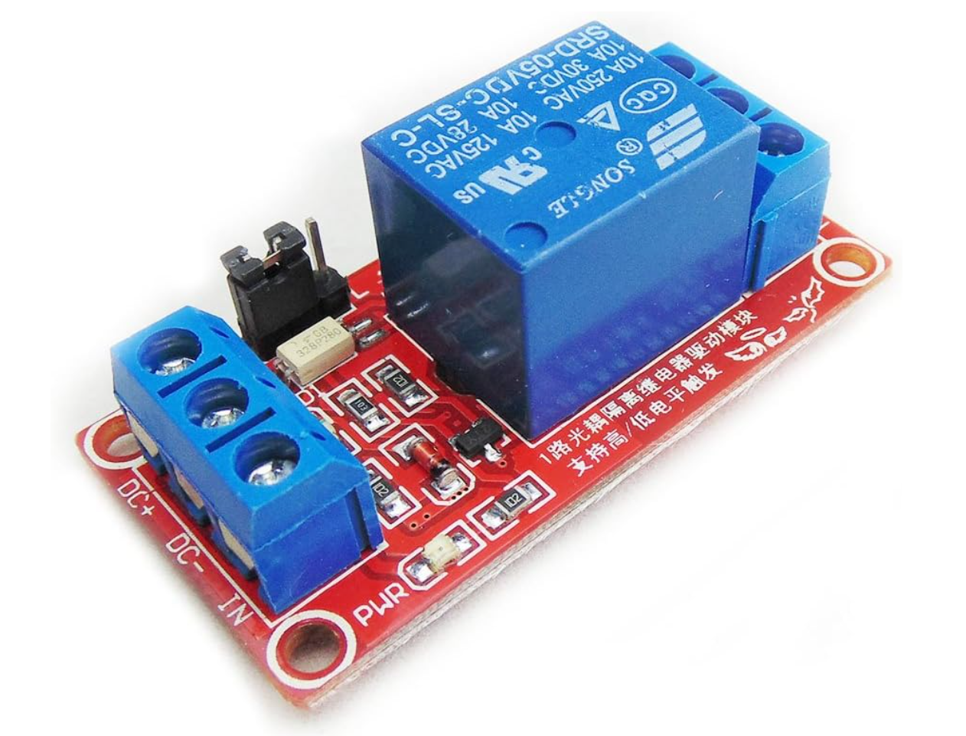

***Figure 19: Relay***

As seen in Figure 19 above, the relay will take in the 5VDC on the left side of the relay, which will function to power the relay for operation. On the right side of the relay module, there are three separate screw terminals, where they are marked for Normally Open, Common, and Normally Closed, where we will utilize the normally open terminal to connect with the target module, so that when the microcontroller indicates to the relay to operate, it will close the circuit, completing it, and allow power to then flow to the motor through the common output.

Due to delays in shipping, implementation on our final design has not begun yet, however, the board that the relay module is mounted on contains screw holes for the board itself to be mounted to an existing source. As a result, this relay will be mounted on each target module, close to the input of the motor, so as to maintain a high capability of reliably delivering power to the motor. While the relay will be receiving an input from the microcontroller, the input will not be directly coming from the microcontroller, but instead from the low power side of the target module, which will contain an DB9 port where sections off of a DB9 cable will be delivering the required signal and DC power meant to operate the relay. This design will allow for a lower amount of magnetic interference to trigger a false positive signal to the microcontroller due to noise in the signal. The design choices mentioned above are reflected below in the attached circuit diagram, Figure 20.

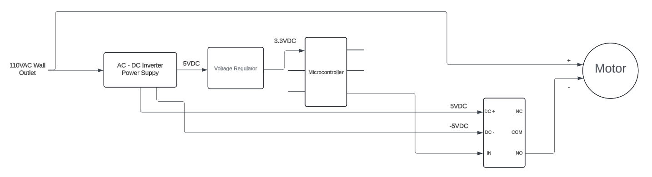

***Figure 20. Relay Circuit Diagram***

***7.4.3 Applicable Relay Marketing and Engineering Requirements***

This section will further discuss the rationale behind the decisions made for what relay module to be used, due to the course requirements of following our set of created marketing and engineering requirements. As mentioned previously, when selecting a relay suitable for the application of this design, we will require one that is both capable of taking a serial communication input such as one received from a microcontroller, as well as 5VDC and outputting 120VAC to our motor, and fitting within our set budget. With these in mind, the following table of marketing requirements details those relevant to the sub-project of relay control and implementation.

**Table 19. Relay Marketing Requirements**

|  |  |
| --- | --- |
| **#MR** | **Marketing Requirements** |
| 1 | The overall system shall comply with safety standards. |
| 3 | The overall system shall not present any risk of harm to the user. |
| 4 | The overall system should have a low cost. |
| 5 | The logic control system shall handle inputs and outputs to the six target modules. |
| 11 | The power system shall relay power to all other subsystems from the existing single phase electrical system. |

Table 19 above details all marketing requirements relevant to the relay implementation and control sub-project. This sub-project contains some global requirements that are relevant for all other sub-projects such as MR #1, 3, and 4, with the exception of MR #5 being particularly relevant to the relay sub-project. It will be necessary for the relay to handle the input signal being received from the microcontroller system sub-project, in order to identify when it is necessary to deliver power to the motor and have the motor function as intended. Marketing Requirement #11 contains verbiage not directly applicable to the relay sub-project as a whole, however, the function of the relay is to deliver power to the motor, which does fit into the requirement itself, allowing MR #11 to be applicable to the sub-project specifically.

The following table contains the Engineering Requirements relevant to the relay implementation and control sub-project.

**Table 20. Relay Engineering Requirements**

|  |  |  |
| --- | --- | --- |
| **# ER** | **Engineering Requirements** | **Related Marketing Requirements** |
| 1 | The overall system shall contain UL listed wiring and components | 1, 3 |
| 2 | The overall system shall meet National Electric Safety code standards | 1, 3 |
| 8 | The overall system shall not be at risk of producing electrocution, fire, or other similar hazards to user of device | 3 |
| 9 | The overall system should not exceed set budget of $300 | 4 |
| 10 | The logic control system shall use serial communication | 5 |
| 11 | The logic control system shall have at least 24 I/O pins for controls and communication, including PWM for motor control and neopixels | 5 |
| 15 | The logic control system shall control motors within each of the six target modules | 6, 13 |
| 20 | The overall system shall contain a power system, including relays and a circuit breaker | 11 |

Engineering Requirements #1, 2, 4, 8, and 9 are all global requirements necessary for all sub-projects to follow. Engineering Requirements #, 10, 11, 15, and 22 are all requirements specifically relevant to the relay implementation and control sub-project.  Requirements #10, 11, and 15 are all in relation to how the relay will communicate with the logic control system sub-project, as it will be necessary for the relay to communicate with the microcontroller contained within the logic control system, such as receiving the serial communication mentioned in ER #10, from the microcontroller to then indicate to the relay when it is necessary to begin delivering power to the motor, indicated in ER #15. Requirement #22 relates to the relay's implementation into the power system. These aforementioned requirements all encompass the relay’s purpose within the system as a whole, which is to deliver power to the motor upon input received from the microcontroller, indicating that a bowling pin has been knocked over. Furthering to the explanation behind each specified Engineering Requirement is the rationale behind the creation of each, which can be found in Table 21 below.

**Table 21. Relay Engineering Requirement Rationale**

|  |  |  |
| --- | --- | --- |
| **# ER** | **Engineering Requirements** | **Rationale** |
| 1 | The overall system shall contain UL listed wiring and components | Reliability is necessary for functional design to be implemented for long period of time |
| 2 | The overall system shall meet National Electric Safety code standards | Safety requirements require all users of buildings power to comply with NEC safety standards |
| 8 | The overall system shall not be at risk of producing electrocution, fire, or other similar hazards to user of device | Overall safety of the system is paramount due to the numerous people in attendance of the event |
| 9 | The overall system should not exceed set budget of $300 | Sponsor has allotted budget to complete project that we are not allowed to exceed |
| 10 | The logic control system shall use serial communication | Already established systems in the target modules are prepared for this |
| 11 | The logic control system shall have at least 24 I/O pins for controls and communication, including PWM for motor control and neopixels | Needs to communicate with 6 motors, 6 neopixels, 6 proximity sensors, and comms with raspberry pi |
| 15 | The logic control system shall control motors within each of the six target modules | Sponsor requires independent control of each target system |
| 20 | The overall system shall contain a power system, including relays and a circuit breaker | Sponsor requested additional electrical safety to current design |

Table 21, listed above, further adds detail to the rationale behind the creation of each Engineering Requirement created, with relation to the sub-project of the relay implementation and control.

***7.4.4 Relay Testing Procedures and Results***

This section will show what testing has been conducted to verify the functionality of the relay, as well as justify the design choices mentioned in previous sections. The majority of these testing procedures were generated according to the engineering requirements mentioned above. Additionally, more tests have been completed to verify that the relay would be able to handle the current output from the motor. All tests mentioned below have been completed at this time and no issues are forecasted.

***Table 22. Relay Testing Procedures and Results***

|  |  |  |  |
| --- | --- | --- | --- |
| **# ER** | **Engineering Requirements** | **Verification** | **Results** |
| 1 | The overall system shall contain UL listed wiring and components | Verify by visual inspection of components regulatory markings or datasheets | Confirmed, parts that have been acquired all contain some form of regulatory marking indicating their safety. |
| 2 | The overall system shall meet National Electric Safety code standards | Safety standards mention specific requirements for compliance with said standards, ensuring that users follow these standards will be measurable by physical inspections | Confirmed, at this time, no integration of parts or materials has resulted in a NEC code violation |
| 8 | The overall system shall not be at risk of producing electrocution, fire, or other similar hazards to user of device | Use a multimeter to ensure that voltage and current levels do not exceed safety standards | Confirmed, tests have been conducted to ensure that the voltage/current being input/output from the target module have not exceeded their ratings. |
| 9 | The overall system should not exceed set budget of $300 | Track costs of purchases to ensure budget is not exceeded | Confirmed, current spending has not exceeded our $300 budget at the time of writing. |
| 10 | The logic control system shall use serial communication | Code will incorporate the serial library and use traditional serial communication | Confirmed, the current code generated has been used to incorporate functional serial communication |
| 11 | The logic control system shall have at least 24 I/O pins for controls and communication, including PWM for motor control and neopixels | Specs and device documentation from whatever microcontroller we go forward with meets need | Confirmed, current selection of microcontrollers contains adequate I/O pins that are necessary for our intended function. |
| 15 | The logic control system shall control motors within each of the six target modules | Use code running a single motor and target system through all viable pin states | Confirmed, tests have been performed to control a target module through each pin state, i.e. resetting a pin to its upright position upon the end of the round. |
| 20 | The overall system shall contain a power system, including relays and a circuit breaker | Circuit diagrams will be designed to incorporate these components, as well as a short can be simulated to verify power is disconnected | Confirmed, circuit diagrams have been created, and a short circuit simulation has been performed. When shorted, power was not flowing to the target module. |

Additionally, tests not directly related to a marketing/engineering requirement have been conducted. The test method and result can be seen in Table 23 below.

***Table 23. Additional Testing and Results***

|  |  |
| --- | --- |
| Test Method | Test Result |
| A current meter was utilized to measure the current output of the motor upon startup and operation, and it’s fault condition, which is stalling the motor. This testing was conducted 5 times total to result an average value for startup, operation, and fault current | The average startup current was found to be ~2.9A. The average operating current was found to be ~1.5A. The average fault current was found to be ~3.9A. |

As seen in the results above, no current reading exceeded the motors’ current rating of 5A. As a result, there should not be a fault incident that will result in damage to the motor. Additionally, as shown in Figure 21. below is an image of how the relays will be wired within the target module. An image of it functioning during tests has not been included due to the relays inability to visually notice that it is operating, but instead by what it is controlling operating. Therefore, a description of how it will operate will be used instead. The relay is receiving +- 5V on the right side of the board from the Auxiliary Power Supply mounted on the target module. It is then receiving a digital signal input from the Arduino Nano based on what it is detecting the bowling pins state to be, either upright or knocked over. On the left side of the board, one relay is then outputting to the clockwise direction on the speed control unit mounted on the target module, and the other relay is outputting to the counterclockwise direction on the speed control unit. This then allows the speed control unit to deliver power to the motor based on what operation it needs to be performing, turning it either clockwise or counterclockwise.

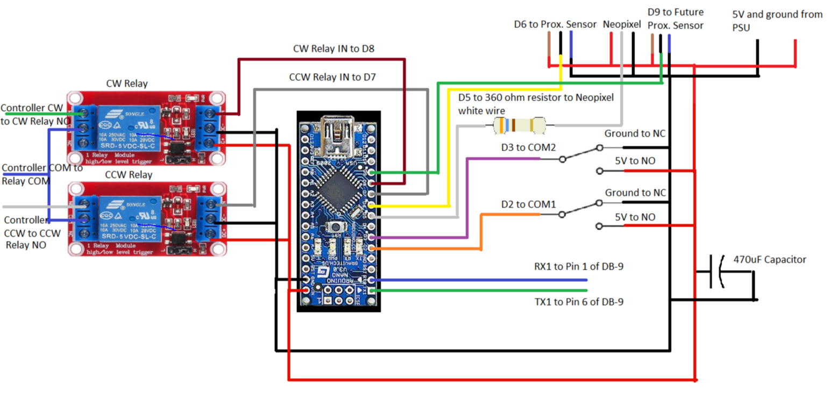

***Figure 21. Relay/Target Module Circuit Diagram***

***7.5 Game State Logic Subsystem***

The game state logic subsystem is responsible for the logic and software to handle the system. This includes decisions pertinent to microcontroller selection and the code to handle the system. This includes utilizing the Arduino environment with a microcontroller (either an Arduino Mega or Adafruit Grand Central M4) to handle controls and inputs from the six target modules and communication to the raspberry pi (handled on the customers end). How this system works is that once the user activates the game through an input to the logic system, through a button press, it transitions into a game state.

***7.5.1 Game State Approach***

The approach used for the game is that of a finite state machine. Figure 22, a Finite State Behavioral Model shows a high-level abstraction of this state machine without the additional software features. After power we enter into an initial state preparing display options and polling for the proper user input through a button to start the system. We then transition into the first game state where we have the game logic located. This is the most rigorous part of the code, including almost all of our additional software options. These are discussed in section 7.5.4 Additional Software Options below.

In the most basic sense this state is the game where after either a certain period (10 seconds as requested by the customer) or one team wins by knocking all three pins over we end the game and stop polling for knocked over pins. We also have the option to move into state 2, a pause where we stop polling and can reset pins knocked over in this period. State 2 can only return to state 1. Once state 1 ends we go to state 3, the repair state. Here we engage the motors through our relay control to reset the targets on the arena and update any scoring information. The scoring works as follows, each team gets 1 point per pin knocked down except for the final pin, which grants 2 points. This means the highest possible score allowed is 4 points for the winning team and 2 points for the second team. The lowest score possible is 0-0, but this will be a very unlikely occurrence. Here is a GitHub repository for the code with the state machine approach built.

[TropicalShorts/RoboBowl at 2bc2061f84954de30fa696b9e1215146f8c98a40](https://github.com/TropicalShorts/RoboBowl/tree/2bc2061f84954de30fa696b9e1215146f8c98a40)

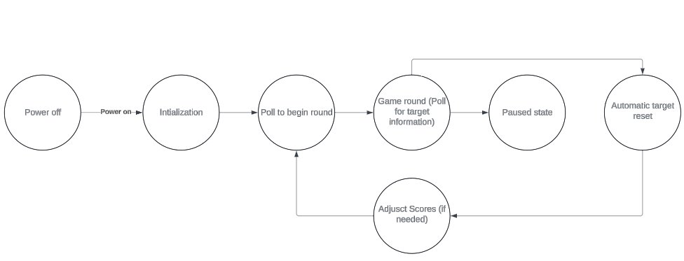

Figure 22: Finite State Behavioral Model

***7.5.2 Main Controller***

The approach we use for this project requires multiple micro controllers. A main one to control the timing and state of the game and an additional one on each target module to handle the inputs and outputs of the system. The main controller will use serial communication to handle communications with the peripheral controllers. Below in figure 23 you can find the flow chart for the main controller. The game begins after being set up. From there based on user input we head into a game state that handles many functions relating to timing, pausing, and reading the status of the pins. If a round is over we enter into our automatic reset and after that it waits for us to finalize the score before moving back to waiting to start the game.

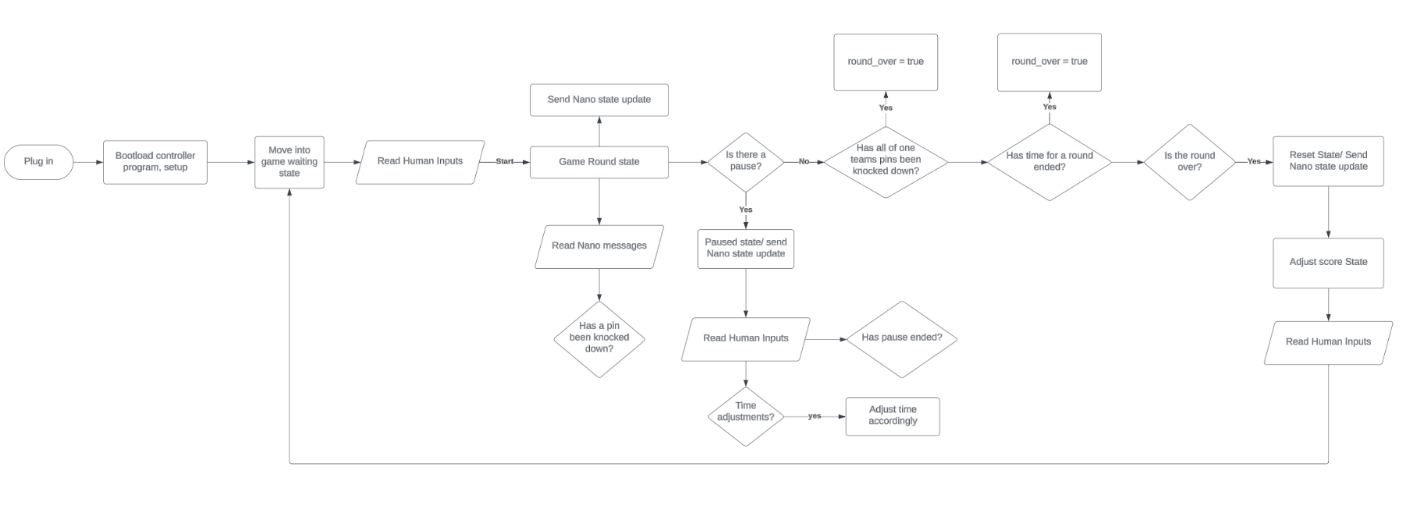Figure 23. Main Controller Flow Chart

***7.5.3 Peripheral Controller***

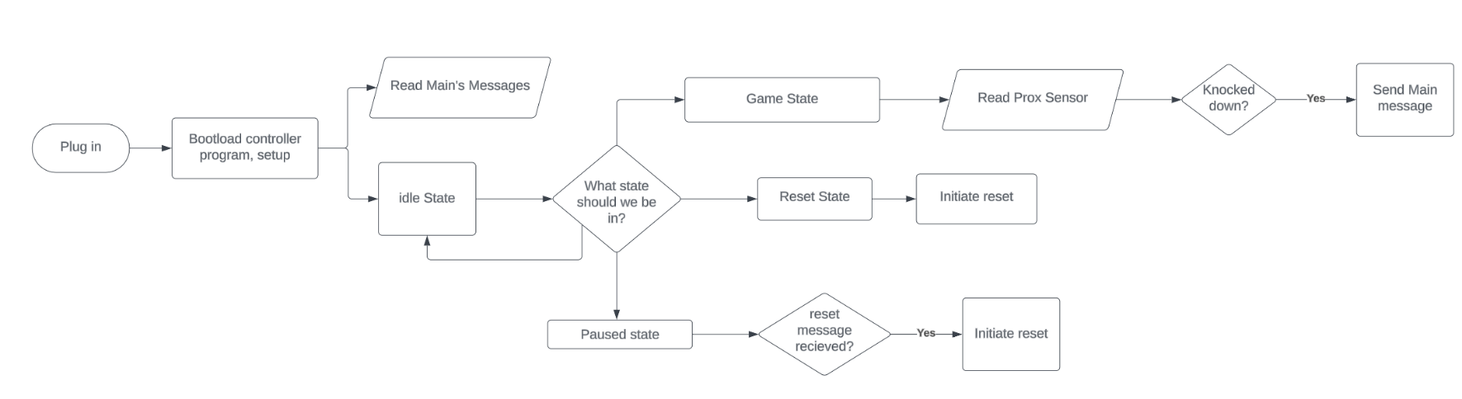The peripheral controller handles the signals coming from the target module. These include the state of the limit switches and the proximity sensor. We use the Arduino Nano for its low cost and ample I/O for each target module. The Arduino Nano controls the relays and the neo pixels from the target module. It knows what to do by the serial communications form our main controller. Figure 24 below shows the flow chart for the peripheral controller. It polls the main controller to see what state we are in and change its state according to that. This works well with our system because it reduces any need to synchronize devices.

Figure 24. Peripheral Controller Flow Chart

***7.5.4 Additional Software Functions***

There are additional software features offered by the code, particularly in the game state. These include inputs to adjust clock time, LED control signaling, specific timing for targets being knocked over, and digitally debounced proximity sensor inputs and buttons. We can get accurate pin knockdown readings in the milliseconds.

***7.5.4 Applicable Marketing and Engineering Requirements***

This system covers the marketing and engineering requirements relevant to the Game State Logic Subsystem. These Marketing requirements are still pertinent request from the consumer. We need the software to handle a large amount of IO to six target modules, manipulate relays, read information from the proximity sensor with a timed element, have logic to handle time and pauses, and communicate with the raspberry pi scoreboard information.

Table 24: Marketing Requirements Applicable to Game State Logic.

|  |  |
| --- | --- |
| **#MR** | **Marketing Requirements** |
| 5 | The logic control system shall handle inputs and outputs to the six target modules. |
| 6 | The logic control system shall have a way to take manual inputs to lock/release pins. |
| 7 | The logic control system shall be able to know the time when targets are knocked over. |
| 8 | The logic control system shall communicate with the raspberry pi-controlled scoreboard. |
| 9 | The logic control system shall have the ability to initiate a pause. |
| 12 | The target module shall have LEDs used to communicate information about the status of targets. |
| 13 | The target module shall be able to lock, release, and reposition targets to their original state. |

***7.5.5 Testing Procedures and Results***

Based on the information in table 24 we need to test and verify the relevant engineering requirements. Below, in table 25, you can find the relevant engineering requirements and results of their testing.

Table 25: Engineering Requirements Applicable to Game State Logic.

|  |  |  |  |
| --- | --- | --- | --- |
| **# ER** | **Engineering Requirements** | **Verification** | **Results** |
| 8 | The logic control system shall use serial communication | Code will incorporate the serial library and use traditional serial communication | Serial communication has been tested between Mega and Nano |
| 9 | The logic control system shall have at least 24 I/O pins for controls and communication, including PWM for motor control and neopixels | Specs and device documentation from whatever microcontroller we go forward with meets need | Ample I/O is provided with the ability for expansion |
| 10 | The logic control system shall be able to receive inputs from six proximity sensors | Prove the ability to produce a different output based on the readings of all six proximity sensors | Two have been tested proximity sensors have been tested at the same time with switches for the other four |
| 11 | The logic control system shall have game state logic to consider things like a round and a pause and what are viable inputs during those times | Create a mock game in software mimicking inputs expected to be seen and observe the code proceeds through the game logic | Demo functional with a pause works |
| 12 | The logic control system shall provide accurate pin state readings | Run code and prove the ability to produce a different output based on the proximity sensors readings | I have tested with two proximity sensors the ability to change outputs dependent on their reading |
| 13 | The logic control system shall control motors within each of the six target modules | Use code running a single motor and target system through all viable pin states | Have simulated running motors with relays but not integrated to full system |
| 14 | The logic control system shall be able to take in a manual input from a button or some physical system to lock pins | Run code receiving input from a button and affecting pin state | Have done this in demo code and worked as intended |
| 15 | The logic control system shall have an interrupt service routine for timed information | Verify by using two proximity sensors and produce an output, accurate to which sensor changed state first | Have tested in DualProximitySensorReading file (available above in 7.5.2) and worked as intended |
| 16 | The logic control system shall have communications with a raspberry pi providing important scoreboard information | Use code running comms to a raspberry pi providing information and the raspberry pi proving it is able to receive that information | Not tested yet, waiting on information from customer on how they want to approach. Approaches have been researched and functionality has been left available |
| 17 | The logic control system shall have an internal score tracker | Use code running a target module and incrementing and printing a variable, representing how many times we have knocked the pin over | Tested and confirmed in Demo code |
| 18 | The logic control system shall be able to take in a manual input to initiate a pause within 1 second. | Run code receiving input from a button, and time the response | Tested, pause response time is very quick |

***7.6 Microcontroller Implementation, Neopixels, and User Interface***

In this section, the microcontrollers selected for use in our design will be discussed as well as the implementation of the neopixels, and the user interface. In the microcontroller section, pros and cons of each controller will be discussed, research done, and testing required. In neopixels, the needs, challenges, and research done will be discussed. In the user interface section, what design considerations are needed as well as what options there are

***7.6.1 Microcontroller Implementation***

The microcontroller is responsible for handling all necessary inputs and outputs in the system. Currently there is no microcontroller at all, all resetting of the targets is done with manual switches directly connected to a relay which turns the motor until the limit switch disconnects power. With a microcontroller, this will be able to be automated and reduces the number of wall power connected components. The microcontroller will also be able to read input from the proximity sensors and button presses, and output to the relays and neopixels. Having one controller do all of this is the approach we originally started with, using the Arduino mega. Below are the relevant Marketing Requirements:

*Table 26: Microcontroller Marketing Requirements*

|  |  |
| --- | --- |
| **#MR** | **Marketing Requirements** |
| 1 | The overall system shall comply with safety standards. |
| 2 | The overall system should be designed with safe transport in mind. |
| 3 | The overall system shall not present any risk of harm to the user. |
| 4 | The overall system should have a low cost. |
| 5 | The logic control system shall handle inputs and outputs to the six target modules. |
| 6 | The logic control system shall have a way to take manual inputs to lock/release pins. |
| 7 | The logic control system shall be able to know the time when targets are knocked over. |
| 8 | The logic control system shall communicate with the raspberry pi-controlled scoreboard. |
| 9 | The logic control system shall have the ability to initiate a pause. |
| 10 | The logic control system and power system should be located near the announcers/judge's table. |
| 12 | The target module shall have LEDs used to communicate information about the status of targets. |
| 13 | The target module shall be able to lock, release, and reposition targets to their original state. |

You can see how most requirements are applicable here, as the microcontroller is part of the overall system, and all the logic control and functionality pertain to the microcontroller. Specifically, MR’s 1-4 deal with the overall system, 5-10 deal with the logic of the game, MR 12 refers to the neopixels, and 13 is the control mechanism for 13. Below is the relevant Engineering Requirements:

*Table 27: Microcontroller Engineering Requirements, Related MRs and Rationale*

|  |  |  |  |
| --- | --- | --- | --- |
| **# ER** | **Engineering Requirements** | **Related Marketing Requirements** | **Rationale** |
| 1 | The overall system shall contain UL listed wiring and components | 1, 3 | Reliability is necessary for functional design to be implemented for long period of time |
| 2 | The overall system shall meet National Electric Safety code standards | 1, 3 | Safety requirements require all users of buildings power to comply with NEC safety standards |
| 7 | The overall system should not exceed set budget of $300 | 4 | Sponsor has allotted budget to complete project that we are not allowed to exceed |
| 8 | The logic control system shall use serial communication | 5 | Already established systems in the target modules are prepared for this |
| 9 | The logic control system shall have at least 24 I/O pins for controls and communication, including PWM for motor control and neopixels | 5 | Needs to communicate with 6 motors, 6 neopixels, 6 proximity sensors, and comms with raspberry pi |
| 10 | The logic control system shall be able to receive inputs from six proximity sensors | 5, 7 | Needs to determine if the pins are up or down |
| 11 | The logic control system shall have game state logic to consider things like a round and a pause and what are viable inputs during those times | 5 | The game will have built in timers and logic related to game rules to ensure that the rounds work as intended |
| 12 | The logic control system shall provide accurate pin state readings | 5, 7 | Requested by sponsor to have accurate score |
| 13 | The logic control system shall control motors within each of the six target modules | 6, 13 | Sponsor requires independent control of each target system |
| 14 | The logic control system shall be able to take in a manual input from a button to lock pins | 6, 13 | Requested by sponsor to add additional game variations |
| 15 | The logic control system shall have an interrupt service routine for timed information | 7, 9 | Timing of when pins are confirmed to be knocked down is critical in determining score and pausing the game when a winner is determined |
| 16 | The logic control system shall have communications with a raspberry pi providing important scoreboard information | 8 | Sponsor plans to use a raspberry pi to control TVs presenting the score and requires communication with their system |
| 17 | The logic control system shall have an internal score tracker | 8 | Must keep track of which pins are down in order to initiate a pause at the end of game, as well as communicating with the score board module |
| 18 | The logic control system shall be able to take in a manual input to initiate a pause within 1 second. | 9 | Requested by sponsor to stop play at any point quickly |
| 19 | The logic control system should be located within 5 ft of a main desk/central location | 10 | Central location is important for ease of use |
| 25 | The logic control system shall run 6 different neopixels (one per target module) to visually provide information about pin state | 12 | Gives visual information about pin status and was requested by sponsor |

***7.6.1.1 Arduino Mega Implementation***

The Arduino mega is a well-documented controller we are familiar with, which has a large number of I/O capability. However, the neopixels need to have a microcontroller within 1-2m, which is much further than where the judges table is from the target modules. This led to a plan to use PWM signals to a microcontroller on each module to control the neopixels, and have it use a range of PWM values to determine the state for the neopixel LEDs, since only 4 colors are needed. The states are pin up, pin down, locked, and game paused each with a corresponding color. So, the mega will eventually receive a total of 12 proximity sensor inputs and several button inputs and have outputs for 12 relays and 6 PWM signals to control neopixel microcontrollers. It will also have a serial link to a raspberry pi which controls the scoreboard, and I2C displays for the user interface. This would have the downsides of limited expansion, a large number of wirings between the judges table and each module, and limited expandability which was a requested feature to have the option to expand. It also would be at a different logic level than the raspberry pi.

***7.6.1.2 Adafruit Grand Central M4 Implementation***

In researching ways to solve these issues, the M4 grand central by Adafruit was found, which is based on the same form factor as the Arduino mega but uses the SAMD51 microcontroller. This accomplishes the same objectives as the mega with the user interface, I2C displays, and raspberry pi communication, but has 8 SERCOM ports which can be configured to be SPI, serial, or I2C. This allows us to better utilize the microcontroller on each target module by allowing us to use serial to talk to each module and let the module microcontroller handle the I/O of each module. Using serial to each module would greatly reduce the wiring needed compared to running everything back to the judge’s table. However, the documentation for the grand central is poor compared to the vast amount for the Arduino mega. This leaves us with a difficult choice, a better solution which may not have the needed documentation, or a less ideal solution that is easier. With this, we went with the better solution and were able to test to see if it would work. There has been much time dedicated to extracting little nuggets of wisdom from old forum posts, as well as reading data sheets, videos about similar microcontrollers, and the large user manual that has relatively little on how we want to use it. Most of the information gathered has been information about the SAMD21 and not the SAMD51 the M4 uses, and a lot of it overlaps, it’s where it doesn't overlap that there is gaps we have to fill in. For example, there is a large comment header on the variants.h file for the SAMD21 that lists pins and their corresponding pads, SERCOM and other information nicely organized. For the SAMD51, you have to look up the information. Additionally, some SERCOM are already used by default, and you have to disable some features like SPI in order to use all 8 SERCOM like we plan to do, with 6 used total for the target modules serial, one for raspberry pi serial, and one for I2C. On the Arduino mega, there are only 4 hardware serial, and while software serial using bit banging is an option, it comes with significant drawbacks that are counterproductive for our use case.

***7.6.1.3 Adafruit Grand Central M4 Final Implementation***

In testing the M4, we were able to successfully implement 5/7 needed serial for the arena. The last two serial required removing declarations of SERCOMs for other things like SPI and a second I2C, which despite multiple approaches only got them partially functional, being able to use the declared serials without errors in the code, but the declared pins being unresponsive to transmitted or received data. Additionally, during testing it was noticed that the rate of the other serial connections was slowed, so offloading each half of the serial to an arduino mega was a balanced approach to solving both issues. The wiring diagram for this is shown below. Note the logic level shifter required to go between the 3.3V M4 and the 5V Arduino. Below that is how the ports in the control box will be wired to the megas. Below that, is how each of the modules will be daisy chained together using the existing wiring. Last is a detailed diagram showing the wiring of how each target module is connected to all the components.

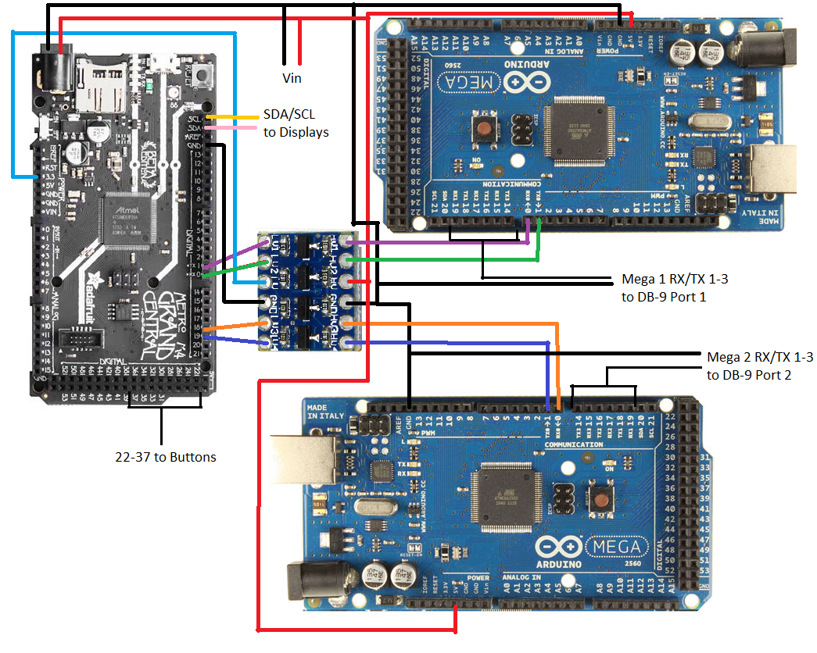

*Figure 25. Grand Central M4 Wiring Diagram*

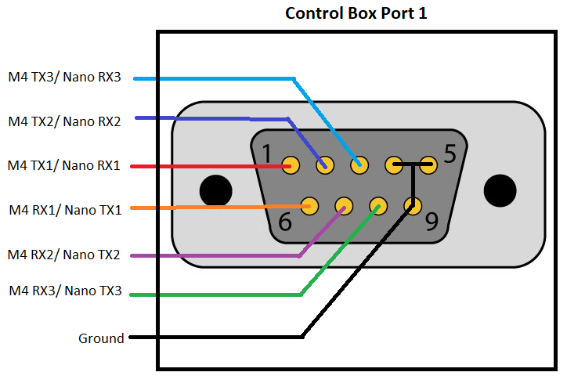

Figure 26. DB9 Control Box Wiring Diagram

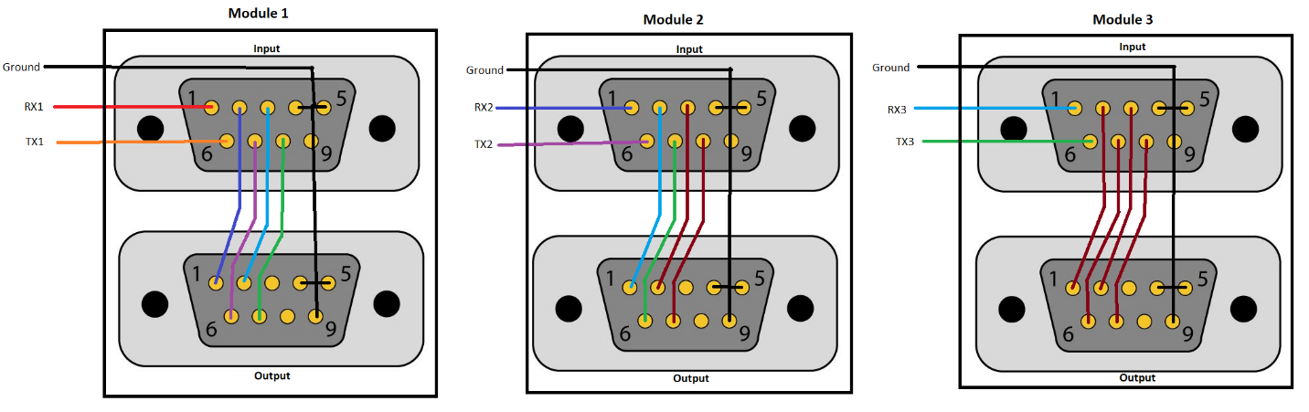  
***Figure 27. DB9 Target Module Wiring Diagram***

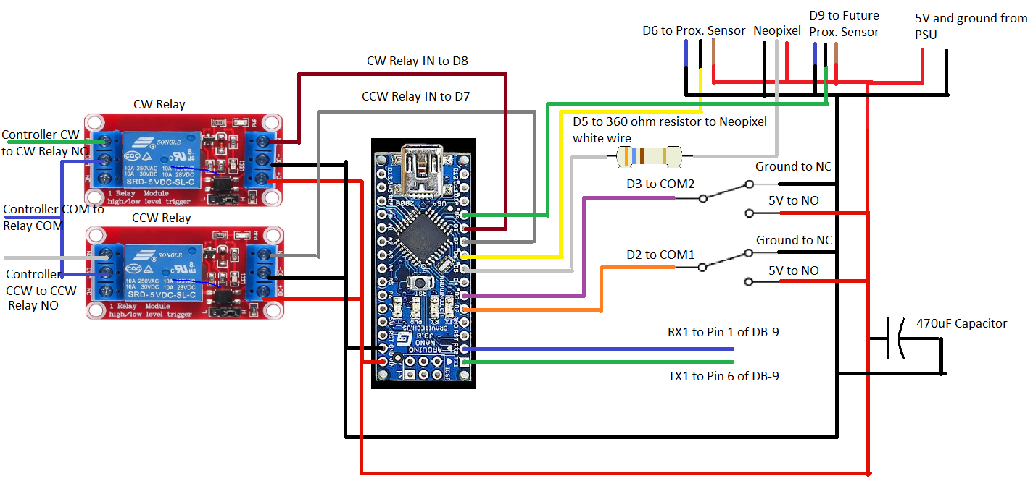

***Figure 28. Target Module Wiring Diagram***

***7.6.1.4 Microcontroller Testing and Verification***

***Table 28. Microcontroller ER Verification and Results***

|  |  |  |  |
| --- | --- | --- | --- |
| **# ER** | **Engineering Requirements** | **Verification** | **Results** |
| 1 | The overall system shall contain UL listed wiring and components | Verify by visual inspection of components regulatory markings or datasheets | Satisfied, all components that will be ordered contain UL listed wiring/components |
| 2 | The overall system shall meet National Electric Safety code standards | Safety standards mention specific requirements for compliance with said standards, ensuring that users follow these standards will be measurable by physical inspections | Satisfied, improvements made to the current power system are compliant. |
| 7 | The overall system should not exceed set budget of $300 | Track costs of purchases to ensure budget is not exceeded | Failed, the budget has been exceeded |
| 8 | The logic control system shall use serial communication | Code will incorporate the serial library and use traditional serial communication | Satisfied, The system uses the required elements |
| 9 | The logic control system shall have at least 24 I/O pins for controls and communication, including PWM for motor control and neopixels | Specs and device documentation from whatever microcontroller we go forward with meets need | Satisfied, The components meet this need |
| 10 | The logic control system shall be able to receive inputs from six proximity sensors | Prove the ability to produce a different output based on the readings of all six proximity sensors | Almost Satisfied, The full system has not been tested yet |
| 11 | The logic control system shall have game state logic to consider things like a round and a pause and what are viable inputs during those times | Create a mock game in software mimicking inputs expected to be seen and observe the code proceeds through the game logic | Satisfied, the mock game was successful |
| 12 | The logic control system shall provide accurate pin state readings | Run code and prove the ability to produce a different output based on the multiple proximity sensors readings | Satisfied, read multiple sensors to determine output |
| 13 | The logic control system shall control motors within each of the six target modules | Use code running a single motor and target system through all viable pin states | Satisfied, testing was successful |
| 14 | The logic control system shall be able to take in a manual input from a button to lock pins | Run code receiving input from a button and resulting in a locked pin | Almost satisfied, The system is capable, but no longer needs to |
| 15 | The logic control system shall have an interrupt service routine for timed information | Verify by using two proximity sensors and produce an output, accurate to which sensor changed state first | Satisfied, testing was successful |
| 16 | The logic control system shall have communications with a raspberry pi providing important scoreboard information | Use code running comms to a raspberry pi providing information and the raspberry pi proving it is able to receive that information | Almost Satisfied, full comunication has not been tested |
| 17 | The logic control system shall have an internal score tracker | Use code running a target module and incrementing and printing a variable, representing how many times we have knocked the pin over | Satisfied, testing was successful |
| 18 | The logic control system shall be able to take in a manual input to initiate a pause within 1 second. | Run code receiving input from a button, and time the response | Satisfied, response was less than 1 second |
| 19 | The logic control system should be located within 5 ft of a main desk/central location | Measure the distance between the microcontroller and the main desk | Satisfied, will sit on announcers table |
| 25 | The logic control system shall run 6 different neopixels (one per target module) to visually provide information about pin state | Use code running 6 neopixel arrays that can change colors based on us feeding different inputs into logic | Almost Satisfied, The full system has not been tested yet |

***7.6.2 Neopixels***

Neopixels are addressable LEDs with existing libraries to create interesting visual feedback on the state of the targets, a feature currently not implemented. Neopixels must be within a short distance of a microcontroller to reliably work, much longer than the spacing from the judges table, and there is one array per module for a total of 6 arrays, each with 60 neopixels. The neopixels were requested to better show contestants and observers what state the game is in. 4 colors were requested, each for the pins being up, down, locked, and the game being paused. There are many guides and a library for their use which is compatible with both the M4 and mega, so solid colors will be straightforward, and if they are determined to be bright enough, we can have varying patterns of intensity for each color to further differentiate them. A ring was designed to hold the fragile neopixels, which comes in quadrants of 15 pixels which are soldered together and are quite delicate without support. This was then 3d printed with transparent PETG (Stronger than PLA) to hold the array in place without obstructing the lights. The images show the reduced thickness of the ring with the improved model, while still having a top and bottom cover for the neopixels.

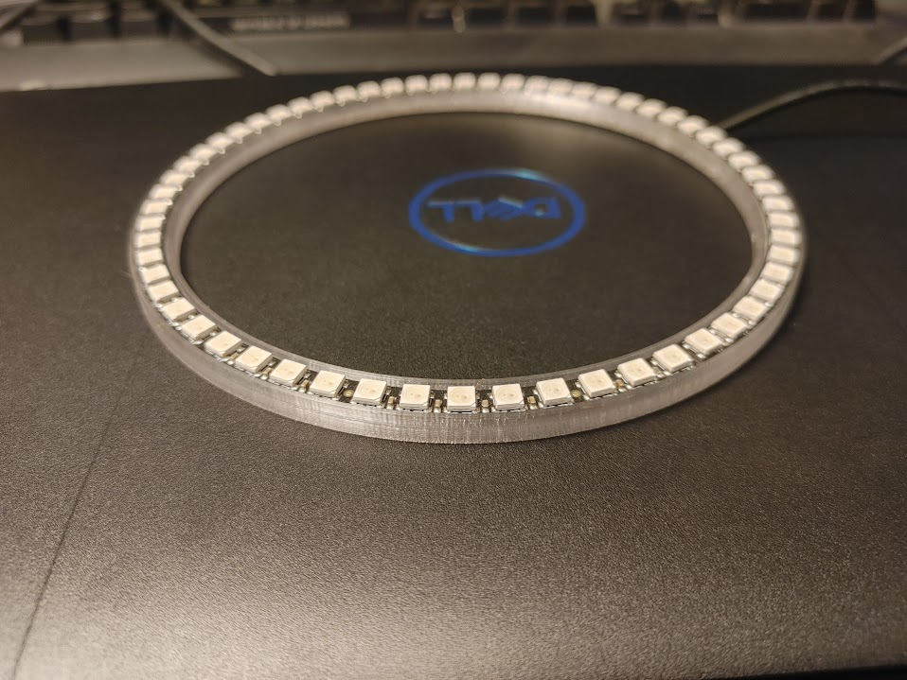

*Figure 29: Neopixels Early Version*

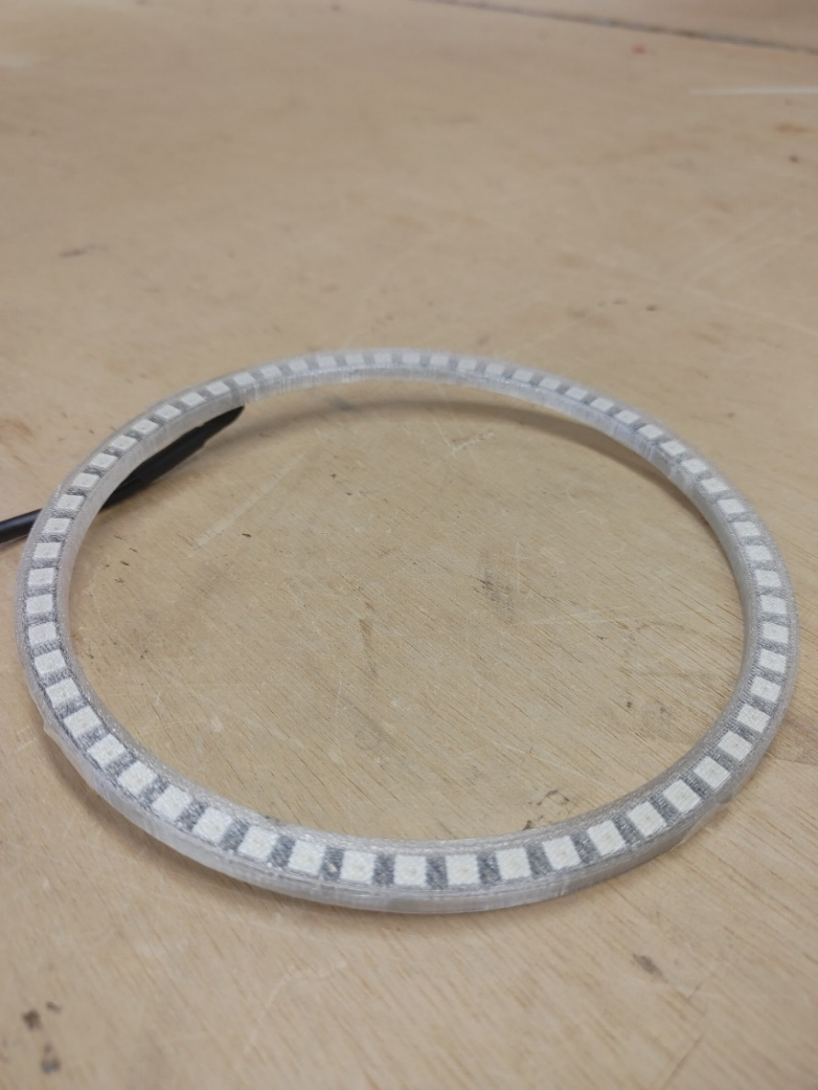

***Figure 30. Neopixels Current Version***

Below is a list of the relevant Marketing Requirements:

*Table 29: Neopixel Marketing Requirements*

|  |  |
| --- | --- |
| **#MR** | **Marketing Requirements** |
| 1 | The overall system shall comply with safety standards. |
| 2 | The overall system should be designed with safe transport in mind. |
| 3 | The overall system shall not present any risk of harm to the user. |
| 4 | The overall system should have a low cost. |
| 12 | The target module shall have LEDs used to communicate information about the status of targets. |

The overall system is still relevant, and MR12 specifically pertains to the Neopixels. Below is the Engineering Requirements:

*Table 30: Neopixel Engineering Requirements, Related MRs and Rationale*

|  |  |  |  |
| --- | --- | --- | --- |
| **# ER** | **Engineering Requirements** | **Related Marketing Requirements** | **Rationale** |
| 1 | The overall system shall contain UL listed wiring and components | 1, 3 | Reliability is necessary for functional design to be implemented for long period of time |
| 2 | The overall system shall meet National Electric Safety code standards | 1, 3 | Safety requirements require all users of buildings power to comply with NEC safety standards |
| 4 | The overall system should allow prebuilt target modules to continue to be dropped into the six different designated locations | 2, 14 | This will make the assembly/disassembly of the arena quicker |
| 5 | The target module should be integrated into the overall system with little complexity (i.e. wire connectors like Push-In connectors or terminal blocks) | 2, 14 | This will allow for easier replacement of parts if need be during competition |
| 7 | The overall system should not exceed set budget of $300 | 4 | Sponsor has allotted budget to complete project that we are not allowed to exceed |
| 25 | The logic control system shall run 6 different neopixels (one per target module) to visually provide information about pin state | 12 | Gives visual information about pin status and was requested by sponsor |

***7.6.2.1 Neopixels Testing and Verification***

***Table 31. Neopixel ER Verification and Results***

|  |  |  |  |
| --- | --- | --- | --- |
| **# ER** | **Engineering Requirements** | **Verification** | **Results** |
| 1 | The overall system shall contain UL listed wiring and components | Verify by visual inspection of components regulatory markings or datasheets | Satisfied, all components that will be ordered contain UL listed wiring/components |
| 2 | The overall system shall meet National Electric Safety code standards | Safety standards mention specific requirements for compliance with said standards, ensuring that users follow these standards will be measurable by physical inspections | Satisfied, improvements made to the current power system are compliant. |
| 4 | The overall system should allow prebuilt target modules to continue to be dropped into the six different designated locations | Verify by taking and replacing a target module and showing that the code/system works identically | Almost satisfied, final assembly required |
| 5 | The target module should be integrated into the overall system with little complexity (i.e. wire connectors like Push-In connectors or terminal blocks) | Time replacement of target module, and comparing against previous time to replace | Almost Satisfied, minimal change from prior design with hook up |
| 7 | The overall system should not exceed set budget of $300 | Track costs of purchases to ensure budget is not exceeded | Failed, the budget has been exceeded |
| 25 | The logic control system shall run 6 different neopixels (one per target module) to visually provide information about pin state | Use code running 6 neopixel arrays that can change colors based on us feeding different inputs into logic | Almost Satisfied, The full system has not been tested yet |

***7.6.3 User Interface***

Additional functions will be needed to be controlled, so the current switch board will not be sufficient, so a new interface is needed. We intend to also present feedback on screens with this interface. We have found backlit screens to use that are addressable using I2C to display information and have been able to successfully test this interface out. We also have modified a case to hold the screens and laser cut wood to hold arcade buttons to control the game state and rest modules, etc.

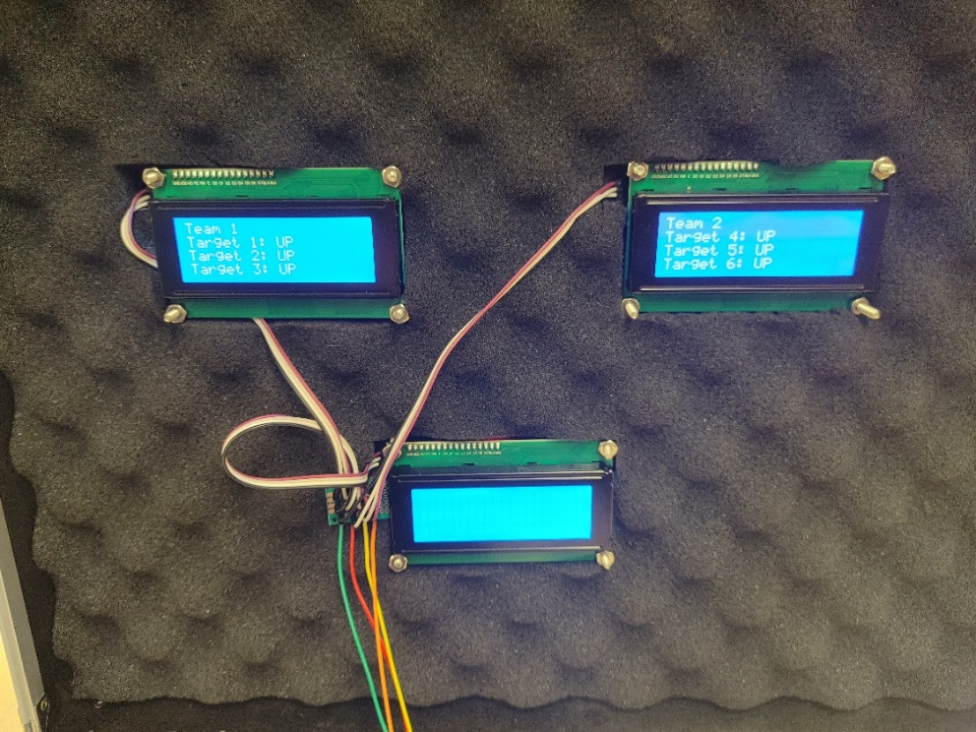

***Figure 31. Control Box LCD’s***

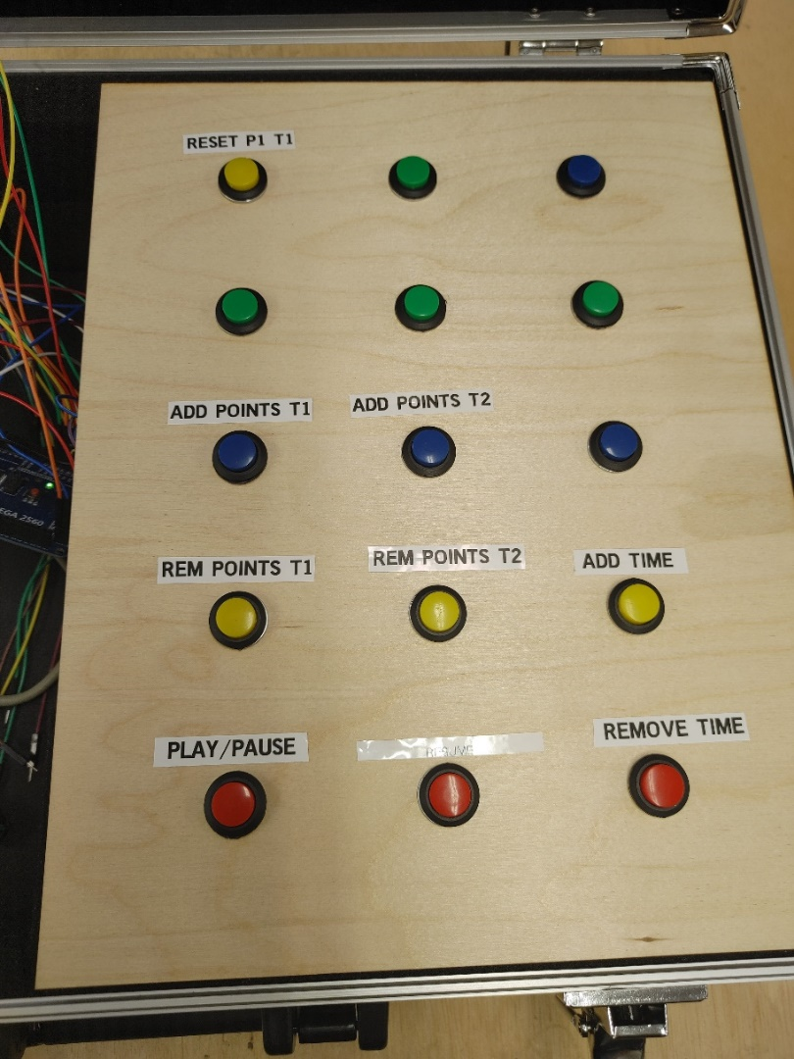

***Figure 32. Control Box Buttons***

Below is the relevant Marketing Requirements:

*Table 32: Control Box Marketing Requirements*

|  |  |
| --- | --- |
| **#MR** | **Marketing Requirements** |
| 1 | The overall system shall comply with safety standards. |
| 2 | The overall system should be designed with safe transport in mind. |
| 3 | The overall system shall not present any risk of harm to the user. |
| 4 | The overall system should have a low cost. |
| 6 | The logic control system shall have a way to take manual inputs to lock/release pins. |
| 9 | The logic control system shall have the ability to initiate a pause. |
| 10 | The logic control system and power system should be located near the announcers/judge's table. |

The user interface must follow the MRs related to the overall system. Other MRs are included as they include inputs into the system. Below is the engineering requirements:

*Table 33: Control Box Engineering Requirements, Related MRs and Rationale*

|  |  |  |  |
| --- | --- | --- | --- |
| **# ER** | **Engineering Requirements** | **Related Marketing Requirements** | **Rationale** |
| 1 | The overall system shall contain UL listed wiring and components | 1, 3 | Reliability is necessary for functional design to be implemented for long period of time |
| 2 | The overall system shall meet National Electric Safety code standards | 1, 3 | Safety requirements require all users of buildings power to comply with NEC safety standards |
| 5 | The target module should be integrated into the overall system with little complexity (i.e. wire connectors like Push-In connectors or terminal blocks) | 2, 14 | This will allow for easier replacement of parts if need be during competition |
| 6 | The logic control system should be securely housed within a protective enclosure | 2 | Protects the circuit and users from harm and establishes a more secure connection |
| 7 | The overall system should not exceed set budget of $300 | 4 | Sponsor has allotted budget to complete project that we are not allowed to exceed |
| 18 | The logic control system shall be able to take in a manual input to initiate a pause within 1 second. | 9 | Requested by sponsor to stop play at any point quickly |
| 19 | The logic control system should be located within 5 ft of a main desk/central location | 10 | Central location is important for ease of use |

***7.6.3.1 User Interface Testing and Verification***

***Table 34. Control Box ER Verification and Results***

|  |  |  |  |
| --- | --- | --- | --- |
| **# ER** | **Engineering Requirements** | **Verification** | **Results** |
| 1 | The overall system shall contain UL listed wiring and components | Verify by visual inspection of components regulatory markings or datasheets | Satisfied, all components that will be ordered contain UL listed wiring/components |
| 2 | The overall system shall meet National Electric Safety code standards | Safety standards mention specific requirements for compliance with said standards, ensuring that users follow these standards will be measurable by physical inspections | Satisfied, improvements made to the current power system are compliant. |
| 5 | The target module should be integrated into the overall system with little complexity (i.e. wire connectors like Push-In connectors or terminal blocks) | Time replacement of target module, and comparing against previous time to replace | Almost Satisfied, minimal change from prior design with hook up |
| 6 | The logic control system should be securely housed within a protective enclosure | When moving enclosure, microcontrollers position does not change | Almost satified, further securing required |
| 7 | The overall system should not exceed set budget of $300 | Track costs of purchases to ensure budget is not exceeded | Failed, the budget has been exceeded |
| 18 | The logic control system shall be able to take in a manual input to initiate a pause within 1 second. | Run code receiving input from a button, and time the response | Satisfied, response was less than 1 second |
| 19 | The logic control system should be located within 5 ft of a main desk/central location | Measure the distance between the microcontroller and the main desk | Satisfied, will sit on announcers table |

***8. Final System Integration, Verification, and Technical Design Overview***

Final system integration will require the interfacing of the different subprojects with Newton’s attic’s already developed system. Our integration will mainly be focused on integrating with the Newton’s attic single target module available to us first and then duplicating the system to account for all six target modules.

***8.1 Final Prototype***

The control box button board prototype is shown below in Figure X. A design was created using Onshape. We laser cut a 1/8th inch board in the UKY innovation center using the Onshape design. Buttons were screwed into the holes and fastened with washers. Ground and power wires were supplied to each of the 15 buttons and soldered to a protoboard containing the button circuit.

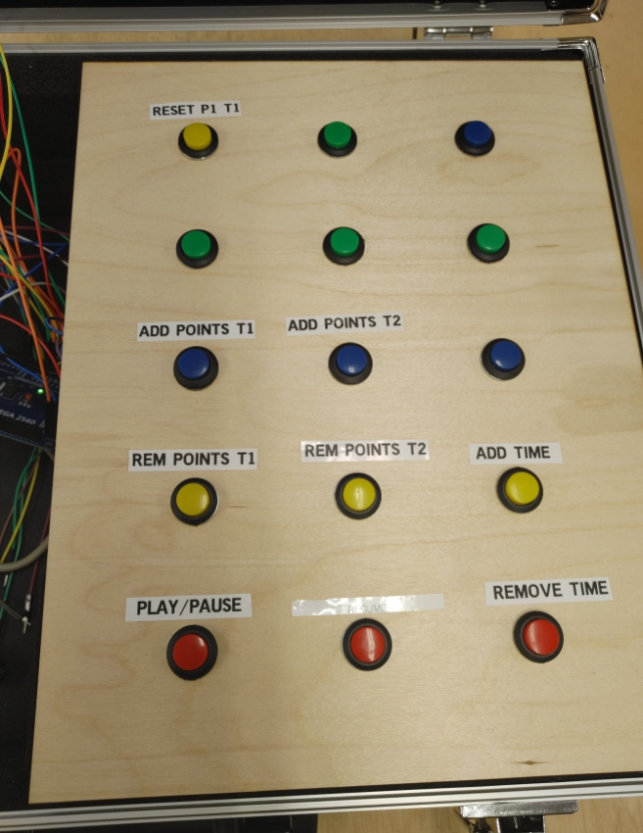

Figure 33: Control Box Button Board Prototype

We also purchased a suitcase with removable foam inserts so that we could separate the wiring and components with foam barriers. We decided to use the foam to hold the button board up. The cut-out section of the prototype control box, that will house the microcontroller is shown below in Figure 34.

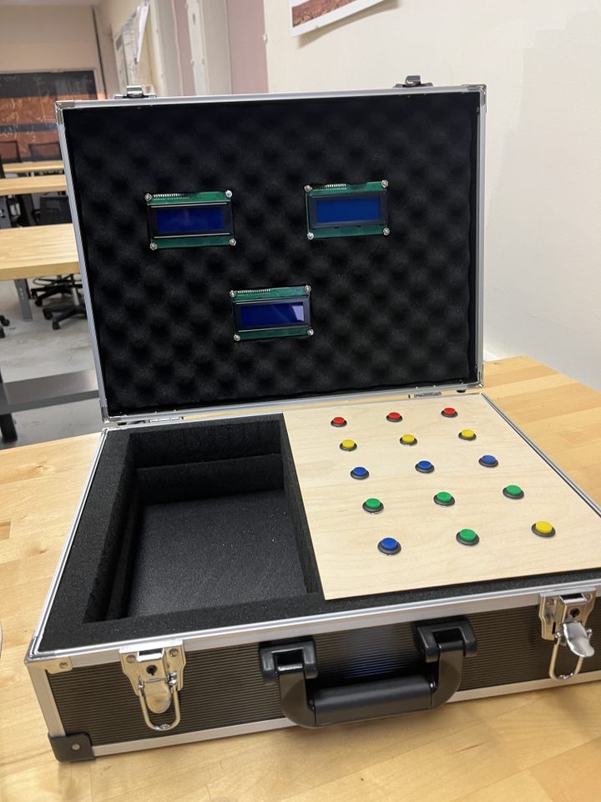

Figure 34: Control Box

The LCD display on the control box is also shown below in Figure 35. We drilled holes into the top of the suitcase and fastened the three LCD screens. We then soldered together the inputs for the screens on a small protoboard and connected wires to each of the screens. Each input was soldered in a row of four including one input from the microcontroller and 3 outputs, one to each screen.

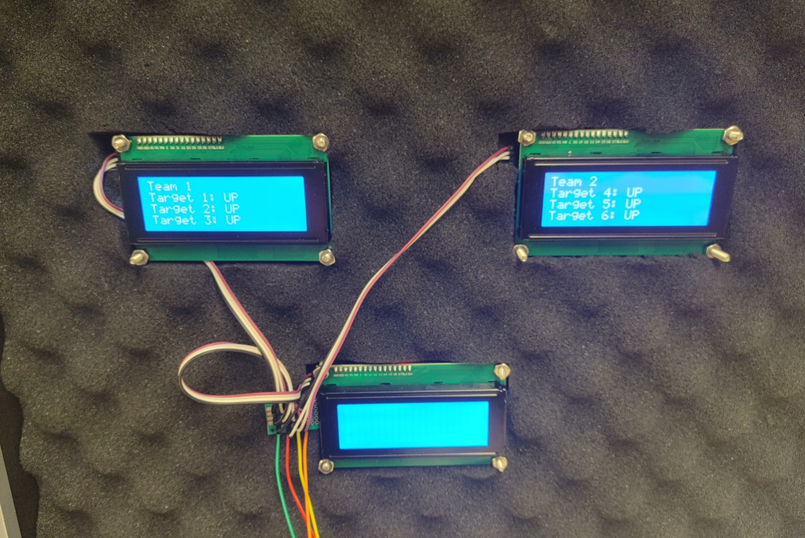

Figure 35: LCD Display Screens Mounted in the Control Box

The control box DB9 ports are shown below in Figure 36. Each pin on both ports was connected to its respective Arduino Mega. The holes were drilled into the control box in order to secure the DB9 ports to the inside of the control box.

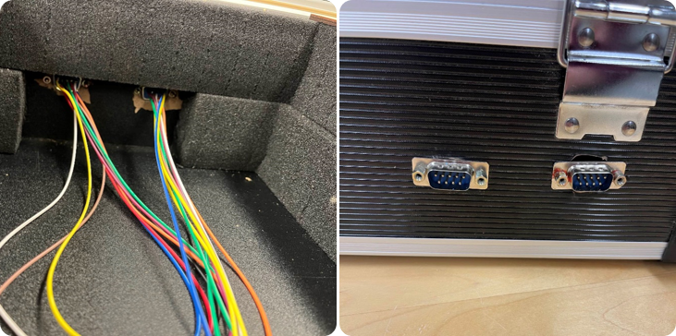

Figure 36: DB9 Ports Mounted in Control Box

The protoboard shown below in Figure 37 was replicated for all seven of the target modules. We drilled holes into the protoboard to secure the DB9 ports and relays. We soldered the DB9 ports following the microcontroller sub-project wiring diagram. The finalized protoboard is shown in Figure 38. The protoboards have been wired accordingly to that found in Figure 39.

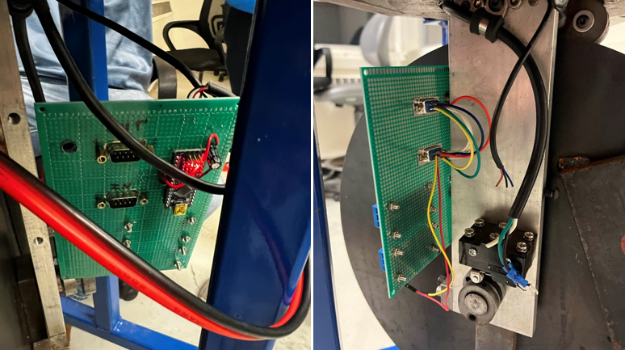

Figure 37: Initial Target Module Protoboard Progress

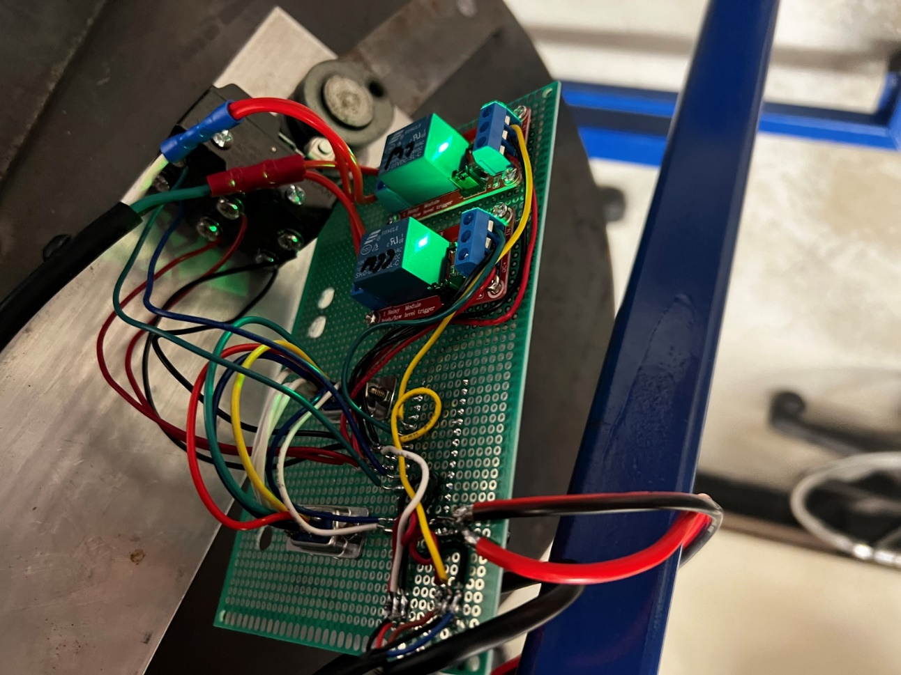

Figure 38: Target Module Protoboard Finalized



*Figure 39. Target Module Protoboard Wiring Diagram*

***8.2 Testing Procedures/Fulfilled & Unfulfilled MR’s and ER’s***

Table 35 below shows which engineering requirements have yet to be tested or tested in full rigor. We expect to satisfy all of the requirements below this Sunday 12/8/24. Once we complete testing with a single target module for all remaining engineering requirements yet to be tested, we will need to schedule a time that works with our customer to test with a full system. Table 36 shows the satisfied engineering requirements as of 12/5/24. All of the requirements that are not currently satisfied are due to a lack of access to all target modules and conflicts with the robot gladiator league schedule. We could not fully implement all of the target module protoboards prior to 12/8/24 because of the robot gladiator league schedule. We failed engineering requirement 7 largely due to the high cost of neopixels. We received approval to exceed our budget as mentioned in the cost section of this report.

Table 35: Engineering Requirements yet to be Satisfied

|  |  |  |  |
| --- | --- | --- | --- |
| **# ER** | **Engineering Requirements** | **Related Marketing Requirements** | **Status** |
| 4 | The overall system should allow prebuilt target modules to continue to be dropped into the six different designated locations | 2, 14 | Almost Satisfied |
| 5 | The target module should be integrated into the overall system with little complexity (i.e. wire connectors like Push-In connectors or terminal blocks) | 2, 14 | Almost Satisfied |
| 6 | The logic control system should be securely housed within a protective enclosure | 2 | Almost Satisfied |
| 7 | The overall system should not exceed set budget of $300 | 4 | Failed |
| 10 | The logic control system shall be able to receive inputs from six proximity sensors | 5, 7 | Almost Satisfied |
| 14 | The logic control system shall be able to take in a manual input from a button to lock pins | 6, 13 | Almost Satisfied |
| 16 | The logic control system shall have communications with a raspberry pi providing important scoreboard information | 8 | Almost Satisfied |
| 19 | The logic control system should be located within 5 ft of a main desk/central location | 10 | Almost Satisfied |
| 25 | The logic control system shall run 6 different neopixels (one per target module) to visually provide information about pin state | 12 | Almost Satisfied |

Table 36: Satisfied Engineering Requirements

|  |  |  |  |
| --- | --- | --- | --- |
| **# ER** | **Engineering Requirements** | **Related Marketing Requirements** | **Status** |
| 1 | The overall system shall contain UL listed wiring and components | 1, 3 | Satisfied |
| 2 | The overall system shall meet National Electric Safety code standards | 1, 3 | Satisfied |
| 8 | The logic control system shall use serial communication | 5 | Satisfied |
| 9 | The logic control system shall have at least 24 I/O pins for controls and communication, including PWM for motor control and neopixels | 5 | Satisfied |
| 11 | The logic control system shall have game state logic to consider things like a round and a pause and what are viable inputs during those times | 5 | Satisfied |
| 12 | The logic control system shall provide accurate pin state readings | 5, 7 | Satisfied |
| 13 | The logic control system shall control motors within each of the six target modules | 6, 13 | Satisfied |
| 15 | The logic control system shall have an interrupt service routine for timed information | 7, 9 | Satisfied |
| 17 | The logic control system shall have an internal score tracker | 8 | Satisfied |
| 18 | The logic control system shall be able to take in a manual input to initiate a pause within 1 second. | 9 | Satisfied |
| 20 | The overall system shall contain a power system, including relays and circuit breakers | 11 | Satisfied |
| 21 | The motors shall run off of 110 VAC | 11 | Satisfied |
| 22 | The logic control system and LEDs shall run off of 5 VDC | 11 | Satisfied |
| 23 | The proximity sensor shall run off of 6-36 VDC | 11 | Satisfied |
| 24 | The target modules each shall run off of one 110V outlet | 11 | Satisfied |

**9. Project Management**

Throughout the section below are breakdowns of current logistics involving our project. This includes topics such as a tentative schedule for our team shown in the Gantt chart, a breakdown for cost of currently purchased items, and a description of each team member’s roles and responsibilities as divided through 5 separate sub-projects.

***9.1 Gantt Chart***

Found in figure 40 below is Team 21’s Gantt Chart. The activities listed below begin first with each sub-projects research period, parts purchasing period, integration period, and testing/verification period. Following each sub-project responsibilities, there is a section for each of the assignments due throughout the remainder of EE 491, senior design. Beside each activity is an estimated start week and planned duration of the activity. The 1st week was intended to indicate the start of this semester, August 26th, and the last week, the 17th week, to be the week of December 16th. The due date for the CDR fell on the 7th week, our current week, which is highlighted by a yellow column in the table. The percentage of completion for each activity can be noted in the “Percent Complete” column.

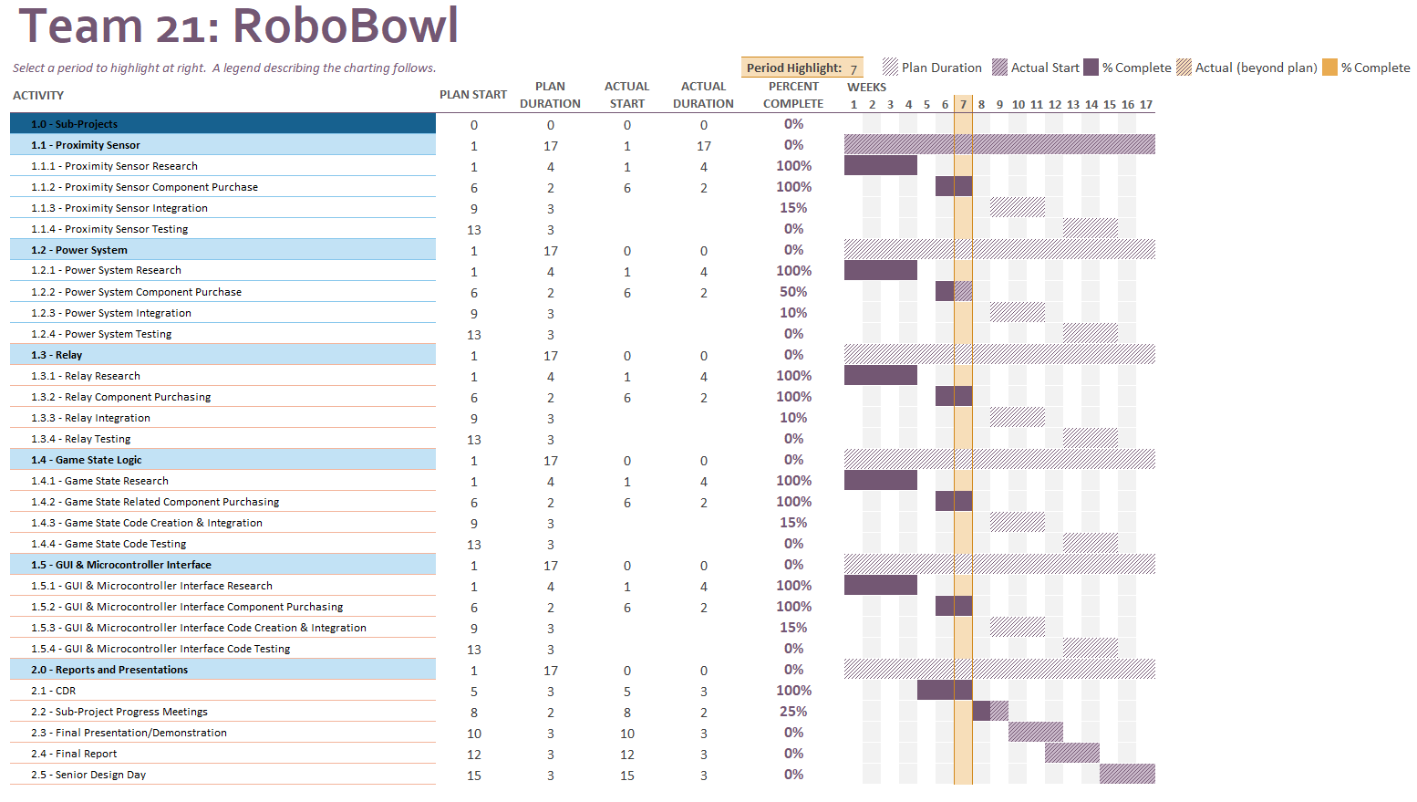***Figure 40. Team 21 Gantt Chart***

***9.2 Work Breakdown***

In table 37 below is a breakdown of the work to be done by each group member. With the complexity of our project new tasks are being updated weekly. With that in mind, tasks broken down below are additionally indicated in the Gantt chart above. Items indicated in the activity column first start with assignments being worked on by the team as whole, specifically ID 1-5. Following that is activities worked on by individual group members, where each activity’s group member is indicated in the people column. Particular activities are built off of previous activities, where they are noted as x.1, x.2, etc. in the predecessor column, to draw back to what activity they relate to. Resources are primarily undecided at this time for most sub-project deliverables as our group members do not have enough previous experience to fully commit to one specific resource. In the event of construction of circuit parts and the overall power system, the senior design lab is noted as the primary resource, as there are numerous tools located within this lab for our group members to utilize to test, and construct circuits appropriately.

Table 37: Work Breakdown

|  |  |  |  |  |  |  |  |
| --- | --- | --- | --- | --- | --- | --- | --- |
| ***ID*** | ***Activity*** | ***Description*** | ***Deliverables/Checkpoints*** | ***Duration (Days)*** | ***People*** | ***Resources*** | ***Predecessors*** |
| 1 | CDR | Complete CDR | CDR | 21 | Team 21 | Microsoft Suite Platforms (Word, Excel) | PDR |
| 2 | Sub-Project Progress Meetings | Meeting with instructors to discuss progress of sub-project | Presentation, Sub-Project Progress Report | 14 | Team 21 | Microsoft Suite Platforms (Word, Excel) | Sub-Project Progress Report |
| 3 | Final Presentation/Demonstration | Demonstrate and showcase our final build of our project to instructors/TA's | Final Design Build, Presentation | 21 | Team 21 | Microsoft Suite Platforms (Word, Excel) | CDR/Sub-Project Progress Meeting |
| 4 | Final Report | Complete Final Report | Final Report | 21 | Team 21 | Microsoft Suite Platforms (Word, Excel) | CDR/Final Presentation |
| 5 | Senior Design Day | Design and Create Poster, along with our final build to present across EE faculty | Poster, Final Design Build | 21 | Team 21 | Microsoft Suite Platforms (Word, Excel) | Final Presentation/Demonstration, Final Report |
|  |  |  |  |  |  |  |  |
| **6** | **Relay's** |  |  |  |  |  |  |
| 6.1 | Relay Research | Research of different types of relay's and decision of particular part | Decision of relay | 28 | Tyler | Google |  |
| 6.2 | Relay Component Purchase | Purchasing of intended relay | Relay | 14 | Tyler | Senior Design Lab | 6.1 |
| 6.3 | Relay Integration | Integration of the relay with other sub-projects/overall design | Relay integration within final design | 21 | Tyler | Senior Design Lab | 6.2 |
| 6.4 | Relay Testing | Testing/verification of functionality in overall design | Datasheets with test results confirming full functionality | 21 | Tyler | Senior Design Lab | 6.3 |
|  |  |  |  |  |  |  |  |
| **7** | **Proximity Sensor** |  |  |  |  |  |  |
| 7.1 | Proximity Sensor Research | Research of different types of proximity sensors and decision of particular part | Decision of proximity sensor | 28 | Chris | Google |  |
| 7.2 | Proximity Sensor Purchase | Purchasing of intended proximity sensor | Proximity sensor | 14 | Chris | Senior Design Lab | 7.1 |
| 7.3 | Proximity Sensor Integration | Integration of the proximity sensor with other sub-projects/overall design | Proximity sensor integration within final design | 21 | Chris | Senior Design Lab | 7.2 |
| 7.3 | Proximity Sensor Testing | Testing/verification of functionality in overall design | Datasheets with test results confirming full functionality | 21 | Chris | Senior Design Lab | 7.3 |
|  |  |  |  |  |  |  |  |
|  |  |  |  |  |  |  |  |
| **8** | **Power System** |  |  |  |  |  |  |
| 8.1 | Power System Research | Research of different types of power system components and decision of particular part's | Decision of power system components | 28 | Landon | Google |  |
| 8.2 | Power System Component Purchase | Purchasing of intended power system component's | Power system component | 14 | Landon | Senior Design Lab | 8.1 |
| 8.3 | Power System Integration | Integration of the power system components with other sub-projects/overall design | Power system component integration within final design | 21 | Landon | Senior Design Lab | 8.2 |
| 8.4 | Power System Testing | Testing/verification of functionality in overall design | Datasheets with test results confirming full functionality | 21 | Landon | Senior Design Lab | 8.3 |
|  |  |  |  |  |  |  |  |
| **9** | **Coding and Microcontroller** |  |  |  |  |  |  |
| 9.1 | Game State Logic Research | Research of different types of game state logic methods and decision of particular part's | Decision of game state logic solutions | 28 | Garrett, and Jackson | Google |  |
| 9.2 | Game State Related Component Purchase | Purchasing of intended game state related component's | Game state related component's | 14 | Garrett, and Jackson | C++ | 9.1 |
| 9.3 | Game State Logic Integration | Integration of the game state logic with other sub-projects/overall design | Game state logic integration within final design | 21 | Garrett, and Jackson | C++ | 9.2 |
| 9.4 | Game State Logic Testing | Testing/verification of functionality in overall design | Datasheets with test results confirming full functionality | 21 | Garrett, and Jackson | C++ | 9.3 |
| 9.5 | GUI and Microcontroller Interface Research | Research of different types of GUI and Microcontroller Interface methods and decision of particular part's | Decision of GUI and Microcontroller Interface solutions | 28 | Garrett, and Jackson | Google |  |
| 9.6 | GUI and Microcontroller Interface Related Component Related Purchase | Purchasing of intended GUI and Microcontroller Interface related component's | GUI and Microcontroller Interface related component's | 14 | Garrett, and Jackson | C++ | 9.5 |
| 9.7 | GUI and Microcontroller Interface Integration | Integration of the GUI and Microcontroller Interface with other sub-projects/overall design | GUI and Microcontroller Interface integration within final design | 21 | Garrett, and Jackson | C++ | 9.6 |
| 9.8 | GUI and Microcontroller Interface Testing | Testing/verification of functionality in overall design | Datasheets with test results confirming full functionality | 21 | Garrett, and Jackson | C++ | 9.7 |

***9.3 Cost***

In Table 38, below is a breakdown of our current accrued costs, including the total amount spent at the bottom of the table. As noted from the total, we are currently over budget by approximately $426.54. This has been communicated with our sponsor and has been approved due to the large cost amount for the Neopixel’s; accounting for more than half of our total cost spent at this time. This part has been specifically requested to be implemented in our design by our sponsor, and therefore has given us permission to exceed the original budget for these items. Our bill of materials is too large to integrate in the document itself, therefore, a hyperlink to the excel sheet has been linked below. The bill of materials can be seen as columns listed to organize what vendors we are purchasing parts from, their respective website, a direct link to the parts themselves, and a description of what the part is. This allows our group to remain organized in what parts have been purchased. Additionally, this table is shared with our sponsor when we are requesting a parts purchase, so that they can be better informed on our current part availability and our intentions behind each part purchase. Each part has an associated cost per item with the part, as well as the total cost if more than one part is purchased. Each part that has been purchased is being used in some fashion, therefore, there are not two separate bill of materials for rebuilding the prototype.

***Table 38. Cost Breakdown***

|  |  |
| --- | --- |
| ***Sub-System*** | ***Total Cost*** |
| **Proximity Sensor**   * No orders placed, proximity sensors provided by sponsor, Newton’s Attic | $0 |
| **Microcontroller**   * Adafruit Grand Central M4 - $39.95 * Arduino Pro Mini – $11.95 * FDTI Friend - $14.75 * Logic Level Converter – $7.95 * Logic Level Shifter – $7.49 * 2 Arduino Nano (3-Pack) – $39.98 * 24 Neopixel Quadrants - $238.80 | $360.87 |
| **Control Box**   * Power Supply - $15.99 * Ethernet Module - $14.99 * 24-Pack of Arcade Buttons - $11.49 * LCD Display Screens - $15.99 * Control Box - $57.00 * Power Jack Plug Adapter (10-Pack) - $7.99 * 2 DB9 Connectors (10-Pack)* - $10.49 per * 2 DB9 Ports (10-Pack) - $7.99 per * 2 DB9 Cables - $13.98 per   * Not used due to incorrect part | $203.36 |
| **Relay**   * 7 Relay‘s (2-Pack) - $8 per | $56 |
| **Power System**   * 2 Power Strips – $13.99 per * 7 Power Supply’s - $11.19 per | $106.31 |
| **Total** | $726.54 |

***Bill of Materials -*** [***Sr Design Order Tracking.xlsx***](https://luky.sharepoint.com/:x:/r/sites/Course_ee490_001-I0NB18RRSt1Rm2-Team21/Shared%20Documents/Team%2021%20Robo%20Bowl/Budget/Sr%20Design%20Order%20Tracking.xlsx?d=w3dca4b34432944fbbe31ae863ecd259c&csf=1&web=1&e=Yq76Dl)

**10. Conclusion and Reflection**

Newton’s Attic has allowed our team, RoboBowl, to modify their current target module system used for their Robot Gladiator League to improve upon current design, as well as add quality of life improvements. This project has achieved the above by adding logic to existing parts such as proximity sensors and relays to allow for more efficient and easy control from a central judges panel. We have additionally added a microcontroller to control a control box used for common game functions such as round control, adding/removing time, adding/removing team points, resetting bowling pins within target module, etc. This report has taken elements from the Critical Design Report, and updated relevant design changes, as well as documented any testing that has been completed to verify functionality of the final system.

Moving forward, if a continuation of our project was given to future Senior Design students there are a few changes that would be recommended for further success. For example, Newton’s Attic provided our team with a few ideas that they would hope to have implemented if we had additional time which include added capability for adding more show effects such as fire, more lights, smoke, music, etc. Additionally, a control box with more buttons, larger displays would be an improvement from what currently exists. Modernizing the system by adding Ethernet ports for communication, versus the existing DB9 ports would improve the current design by creating easier accessibility to components that people would be more likely to have on hand. Finally, implementing more efficient controls via newer, and smaller components for functions such as locking the bowling pin in place would benefit our sponsor greatly, as this originally was a request made from our sponsor that was later dropped due to added complexity creating complications.

Using the knowledge gained from completion of this project, there are multiple things that our team would have done differently. This includes better communication with our sponsor surrounding our design ideas, and decisions for parts. This could have completed our design process much more quickly had we not spent a large amount of time needlessly debating what design best fits the sponsors’ needs, without first consulting them. Additionally, our team would have requested to receive more input from sponsors on what they are hoping to receive from us, as this would have additionally sped up our design process. Our team would request that we receive a spare target module solely for the purpose of testing and implementation, that they do not require to have returned biweekly. This would have allowed our group to complete implementation at a faster rate, as often times we would be receiving new parts at the same time that we would be returning our target module back to our sponsor for their competitions. Our team would have liked to follow our work structure/schedule more closely as we deviated frequently. Additionally, we would have chosen to begin working on physical implementation more closely to the beginning of the semester, which would have given us more time to complete our system. Finally, we would have liked to narrow down design decisions such as microcontroller decision, lack of locking mechanism implementation, communication port decision (Ethernet vs. DB9), giving us more time to do actual testing and implementation. Overall, this opportunity has provided our team with valuable experience of working on a large, complex system and many useful lessons were gathered from this.

**11. References**

* IEC 60204-1 “Safety of Machinery – Electrical equipment of machines – Part 1: General Requirements.”
* “Behavioral Models | Lucidchart,” *lucid.app*. https://lucid.app/lucidchart/94425f61-28d3-4ab3-bc61-62299737b175/edit?viewport_loc=1%2C-11%2C1936%2C1117%2C0_0&invitationId=inv_3ffdb287-3aa1-433c-bb15-d14cb08d660e (accessed Mar. 25, 2024).
* “Brainstorming and ideation | Lucidspark,” *lucid.app*. https://lucid.app/lucidspark/a040d54e-c3e2-407e-96c9-f1fa570ac726/edit?invitationId=inv_c0558562-d11a-43b3-9718-6cc412632fab (accessed Mar. 25, 2024).
* “Resource Library,” *Electrical Safety Foundation*. https://www.esfi.org/resource-library/ (accessed Mar. 25, 2024).
* Ralph Michael Ford and C. S. Coulston, *Design for electrical and computer engineers : theory, concepts, and practice*. Boston, Mass.: Mcgraw-Hill, 2008.
* Main Power Supply Image: <https://m.media-amazon.com/images/I/41QJErKcteL._SY445_SX342_QL70_FMwebp_.jpg>
* Auxiliary Power Supply Image: <https://m.media-amazon.com/images/I/51Zih9Iw03L._AC_SX466_.jpg>
* Power Strip Image: <https://m.media-amazon.com/images/I/61aQEAIChdL._AC_SX466_.jpg>

**12. Appendix**

Below is our team’s set of AHP tables used to determine weights for the Objective Tree shown above in section 5.2. Additionally, a link has been attached to our GitHub that stores all code utilized for our final design.

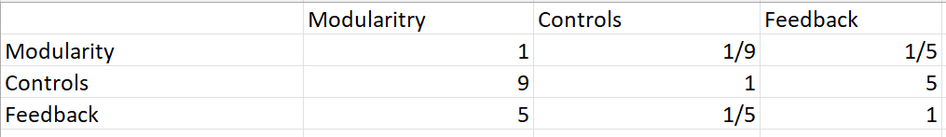

Figure 41. AHP Table for Safety

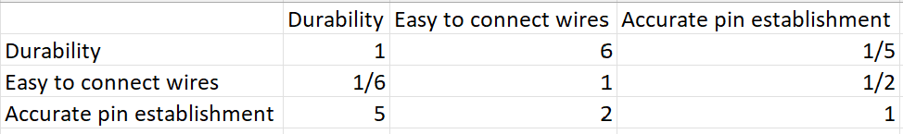

Figure 42. AHP Table for Target Module

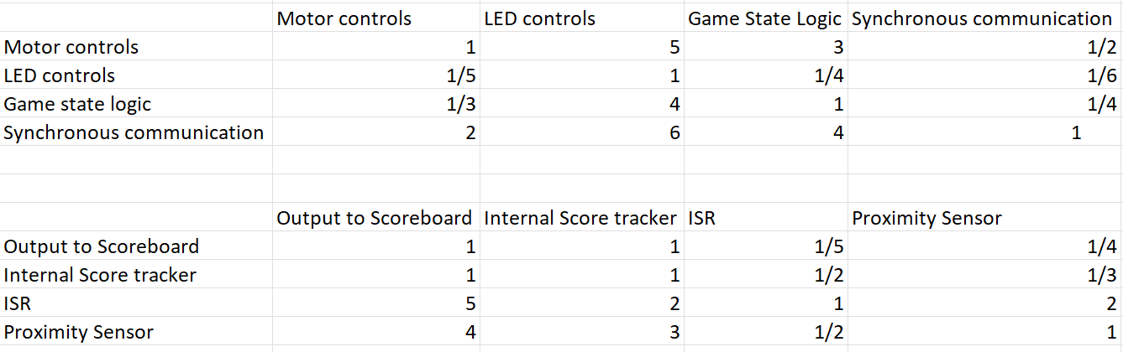

Figure 43. AHP Table for Logic Control and Power



*Figure 44. Grand Central M4 Wiring Diagram*



*Figure 45. DB9 Control Box Wiring Diagram*



*Figure 46. DB9 Target Module Wiring Diagram*



*Figure 47. Target Module Wiring Diagram*

*GitHub Link - https://github.com/TropicalShorts/RoboBowl/tree/2bc2061f84954de30fa696b9e1215146f8c98a40*